Date of teaching
Unit 3: My friends
Lesson 2: A closer look 1
* Warm-up: “Sing and Dance: Head shoulder knees and toes” game Lead in
I. Wordbook
1. confident (adj)
2. caring (adj)
3. active (adj)
4. careful (adj)
5. creative (adj)
6. shy (adj)
7. kind (adj)
8. clever (adj)
Task 1: Matching. Students work in pairs to match the words with the correct pictures.
Task 2: Read the descriptions and match with the correct words.
Task 3: Game: What’s she/he like?
II. Pronunciation
Task 4: Pronunciation: /b/ vs /p/. Listen and repeat.
Task 5: Practice the chant.
III. Production
Task 6: Game: “Up and down”
* Homework

Procedures
Stage | Stage aim | Procedure | Interaction
Warm-up  5 mins | To review body parts, recall students’ vocabulary. | * “Head shoulder knees and toes” sing and dance  Teacher explains the song rules: Students have to touch the body parts that the song calls out. Who gets wrong action is out of the game. | T-Ss
Lead-in  6 mins | To lead in the topic. | Lead in: How can we describe our friends’ personalities?  Teacher asks students to say some personalities:  Suggested answers:  funny, active, lazy, hard-working, …  Task 1: Matching. Students work in pairs to match the words with the correct pictures: Check  (Teacher can help students by describing the pictures.)  Answer key:  1. c (caring) 2. e (active)  3. d (hard-working) 4. a (funny)  5. b (confident) | T-Ss
Presentation  (Vocab-  pre-teach)  9 mins |  | Vocabulary  - Teacher introduces the vocabulary by:  + providing the synonym/antonym of the words  + providing the definition of the words  1. confident (adj): [explanation]  2. caring (adj): [explanation]  3. active (adj): [explanation]  4. careful (adj): [explanation]  5. creative (adj): [explanation]  6. shy (adj): [antorym]  7. kind (adj): [explanation]  8. clever (adj): [synonym]  - Teacher asks students to repeat and practice pronouncing the words.  - T checks their memory with an Anagram game, drag the letters to the correct position   | T-Ss
Practice  10 mins | To practice the targeted language  (adjectives) and the background knowledge.  To practice the targeted  language (adjectives) and the background knowledge verbally | Task 2: Read the descriptions and match with the correct words. (p. 28)  - Teacher asks students to work individually.  - Then discuss with a partner.  - Teacher checks and corrects (if needed).  Answer key:  1. creative 2. kind 3. friendly  4. careful 5. clever  Task 3: Game: What’s she/he like?  - Students work in groups.  - Teacher asks students to write at least 2-3 personalities to describe each members.  - Teacher spin the wheel, beginning with “What’s her/his name?”  Her/His name is Trang.  - What does she/he looklike?  She/He is tall and thin.  - What’s she/he like?  She/He is very careful and smart.   | S  Ss  T-Ss  Group work  T-Ss
Practice  5 mins | To help students  practice pronunciation the sound in words. | PRONUNCIATION  Task 4: Pronunciation: /b/ and /p/. Listen and repeat. Circle the words you hear.  - Teacher has students lister to the recordings and stops to let students repeat each word.  - Students work independently to circle the words they have listened.  Task 5: Listen. Practice the chant.  - Teacher plays the recording twice.  - Students practice with a partner.  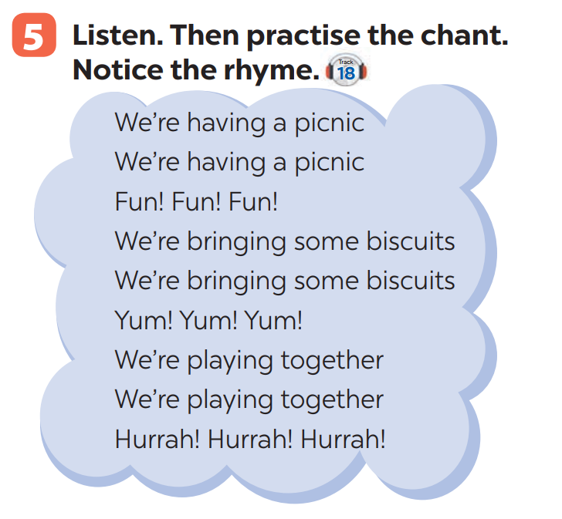 | T-Ss  S  T-Ss  Ss-Ss
Production  7 mins | To recognise the targeted vocabulary and sounds. | Task 6: Game: “Up and down”  - Teacher explains the rules:  - Round 1: Teacher says 1-15 personalities that students have learnt in the lesson. Students stand up for the positive ones, sit down for the negative ones.  - Round 2: Teacher says 1-15 words containing the sound /b/ and /p/. Students stand up for the ones with the “b” sound, sit down for “p” sound.  - Students plays on groups. | T-Ss  Group work
Wrap-up  2 mins | To consolidate what students have learnt in the lesson. | Teacher asks students to talk about what they have learnt in the lesson. | T-Ss
Homework  1 min | To prepare vocabulary for the next lesson: A closer look 2. | Do the exercises in the workbook. | T-Ss

