Week: 06 Date of planning: ...../ …../ …..

Period: 16 Date of teaching: …../ …../ …..

UNIT 3: MY FRIENDS

Lesson 2: A closer look 1

I. OBJECTIVES: By the end of the lesson, students will be able to:
- Use adjectives to describe about people’s personality;
- Pronounce correctly the sound /p/ and /b/ in isolation and in context.
1. Knowledge:
* Vocabulary: Personality adjectives
* Grammar: Verbs be and have and the present continuous
2. Skills: Listening, speaking and reading
3. Attitude: To teach students to work hard, love their school and friends
4. Competences: Co-operation, self-study, using language to do exercises
II. TEACHING AIDS:
1. Teacher:
- Grade 6 textbook, Unit 3: A closer look 1
- Smart TV, cards, visual aids
- sachmem.vn
2. Students: Textbooks, notebooks, studying equipment,...
III. ANTICIPATED PROBLEM & SOLUTIONS:
1. Students may lack knowledge about some lexical items.
→ Solution: Provide students with the meaning and pronunciation of some lexical items.
2. Students may have underdeveloped listening, speaking and co-operating skills.
→ Solution: Play the recording many times if necessary.
Encourage students to work in pairs, in groups so that they can help each other.
3. Some students will excessively talk in the class.
→ Solution: Define expectation in explicit detail.
Have excessive talking students practise.
Continue to define expectations in small chunks (before every activity).
IV. PROCEDURES:
1. WARM-UP (5’)
* Aim: To review on people’s body parts, recall students’ vocabulary.
* Content: Game: ‘Network’ (write words for body parts or describe parts of the body).
* Outcome: Students write correct words on the board.
* Organization of implementation:
Teacher’s & Students’ activities | Content
* Warm-up: T – Ss  - T calls 4 ss to stand in front of the class and students have to touch the body parts that teacher calls out. Who does wrong actions is out of the game.  * Lead-in  → “Today, we are going to learn some personality adjectives”. | * Game: Simon says  Simon says  * Suggested answers:  1. eyes, nose, hair, head,...  2. long, short, fat, slim,...
2. PRESENTATION (6’)
Vocabulary
* Aim: To teach students some personality adjectives.
* Content: Some vocabulary about personality.
* Outcome: Read and recognize the meaning of the words.
* Organization of implementation:
Teacher’s & Students’ activties | Content
* Pre-teach vocabulary: T – Ss  - T uses different techniques to teach vocabulary (pictures, situation, explanation,…).  - Follow the seven steps of teaching vocabulary.  - Repeat in chorus and individually.  - Copy all the words.  * Checking vocab: Matching. | * Vocabulary:  - confident (adj): tự tin (explanation)  - caring (adj): quan tâm, lo lắng (explanation)  - active (adj): năng động (antonym)  - careful (adj): cẩn thận (antonym)  - creative (adj): sáng tạo (explanation)  - shy (adj): e thẹn, nhút nhát (antonym)  - kind (adj): tốt bụng (synonym)  - clever (adj): thông minh (synonym)
3. PRACTICE (13’)
Task 1 (4’)
* Aim: To teach students some personality adjectives and practice with these adjectives.
* Content: Match the adjectives to the pictures.
* Outcome: Students write the correct key on the board.
* Organization of implementation:
Teacher’s & Students’ activities | Content
Task 1: T – Ss  - Ss work in pairs to match the words with the correct pictures.  - T can help Ss by describing the pictures.  - Check and confirm the correct answers. | Task 1: Match the adjectives to the pictures.  * Answer key:  1. c (caring)  2. e (active)  3. d (hard-working)  4. a (funny)  5. b (confident)
Task 2 (5’)
* Aim: To practice the targeted language (adjectives) and the background knowledge.
* Content: Use the adjectives in the box to complete the sentences.
* Outcome: Students say the correct answers (pair work).
* Organization of implementation:
Teacher’s & Students’ activities | Content
Task 2: T – Ss ; Ss – Ss  - T asks Ss to work individually.  - Ss find the correct adjectives to fill the blank in each sentence.  - Then discuss with a partner to find out the key words  - T checks and corrects (if needed).  -T has ss look at the sentences they ‘ve made to give the structure of describing someone’s appearance and character  - SS make examples  - T shows 2 pictures of Nam and Lan and asks ss to describe their body shape and personality  - SS discuss in pairs to talk about it in 2-3 mins  - T calls some ss to do orally. | Task 2: Use the adjectives in the box to complete the sentences. Pay attention to the highlighted words/ phrases.  * Answer key:  1. creative 2. kind  3. friendly 4. careful  5. clever  Describing a person :  Form : S+ am/ is/are + adj
Task 3 (4’)
* Aim: To provide students with freer practice with personality adjectives.
* Content: Game: ‘Why do I love my friends?’
* Outcome: Students say perfect sentences aloud (group work).
* Organization of implementation:
Teacher’s & Students’ activities | Content
Task 3: T – Ss ; Ss – Ss  - Have Ss work in groups and play the game.  - T asks Ss to write at least two or three personalities to describe each members.  - T asks Ss to read out, beginning with:  ‘I love … because he/she is …, … and …, …’ | Task 3: Game: Why do I love my friends?  * Suggested answers:  1. I love Trang because she is kind, creative and funny.  2. I love Minh because he is smart, caring and friendly.
4. PRESENTATION (3’)
Pronunciation
* Aim: To help students to identify how to pronounce the sounds /b/ and /p/.
* Content: Pronunciation: Sounds /b/ and /p/.
* Outcome: Read and pronounce the sounds /b/ and /p/.
* Organization of implementation:
Teacher’s & Students’ activities | Content
* T – Ss ; Ss – Ss  - T introduces two sounds /b/ and /p/ to Ss and lets them watch a video about how to pronounce these two sounds.  - Ss practice pronouncing the two sounds.  - T asks Ss to give some words they know containing these sounds. | * Sound /b/ and /p/  Example:  - /b/: bean, back, balloon, …  - /p/: pen, pick, pool, …
5. PRACTICE (8’)
Task 4 (3’)
* Aim: To help students practice pronouncing these sounds correctly in words.
* Content: Listen and repeat. Circle the words you hear.
* Outcome: Read and know how to pronounce the sounds /b/ and /p/.
* Organization of implementation:
Teacher’s & Students’ activities | Content
Task 4: T – Ss ; Ss – Ss  - T has Ss listen to the recordings and stops to let Ss repeat each word.  - Ss work independently to circle the words they have listened. | Task 4: Listen and repeat. Circle the words you hear.  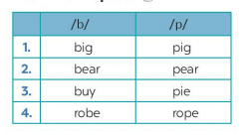  * Answer key:  1. pig 2. pear  3. buy 4. rope
Task 5 (5’)
* Aim: To help students pronounce the sounds /b/ and /p/ in context.
* Content: Listen and practice the chant.
* Outcome: Whole class practise the chant exactly.
* Organization of implementation:
Teacher’s & Students’ activities | Content
Task 5: T – Ss  - Ask Ss to listen while T plays the recording.  Clap or use an instrument like a tambourine to help Ss notice the rhyme.  - Play the recording again and ask Ss to chant along.  - Tell them to pay attention to the words that have the sounds /b/ and /p/ and the rhyme. | Task 5: Listen. Then practise the chant. Notice the rhyme.  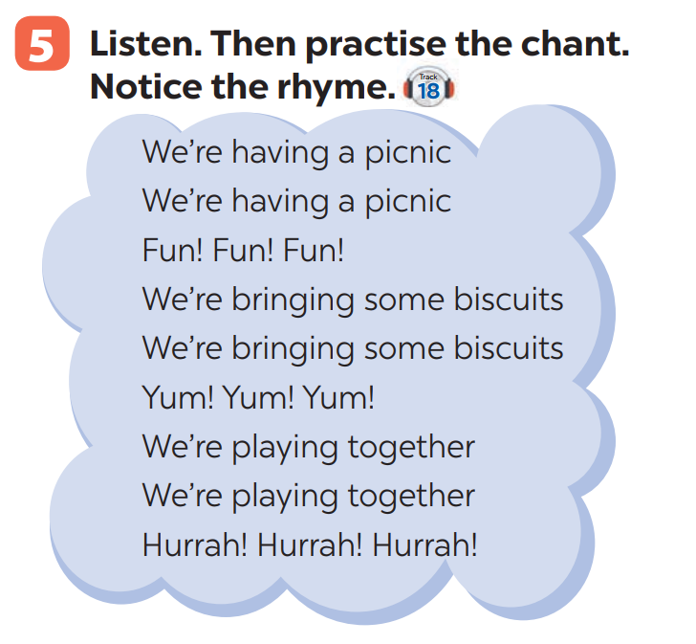
6. PRODUCTION (5’)
* Aim: To recognise the targeted vacabulary and sounds.
* Content: Game ‘Up and down’ (revise words about personalities,...).
* Outcome: Students plays in groups.
* Organization of implementation:
Teacher’s & Students’ activities | Content
* T – Ss ; Ss –Ss  - T explains the rules.  - Ss plays on groups. | * Game: Up and down  - Round 1: T says 1-15 personalities that Ss have learnt in the lesson. Ss stand up for the positive ones, sit down for the negative ones.  - Round 2: T says 1-15 words containing the sound /b/ and /p/. Ss stand up for the ones with the “b” sound, sit down for “p” sound.
7. CONSOLIDATION (3’)
* Aim: To consolidate what students have learnt in the lesson.
* Content: Vocabulary about personalities and how to pronounce the sounds /b/ and /p/.
* Outcome: Say aloud some words they remember from the lesson.
* Organization of implementation:
Teacher’s & Students’ activities | Content
- T asks Ss to talk about what they have learnt in the lesson. | - Vocabulary about personalities.  - How to pronounce the two sounds: /b/ and /p/.
8. HOMEWORK (2’)
* Aim: To review the lesson and prepare for the next lesson.
* Content: Review the lesson, prepare the next lesson and do exercises in the workbook.
* Outcome: Students’ textbooks and workbooks.
* Organization of implementation:
Teacher’s & Students’ activities | Content
- T reminds Ss to do homework and prepare the new lesson. | - Do exercises in Workbook.  - Prepare: Unit 3 – Lesson 3: A closer look 2.

* EVALUATION:
........................................................................................................................................................................................................................................................................................................................................................................................................................................................................

