Date of planning:…………..  Date of teaching: ………..…  WEEK: … | Peroid 60 : UNIT 7 : TELEVISION  Lesson 6 : SKILLS-2/ Listening and Writing
THIS UNIT INCLUDES:
Vocabulary  - TV programmes  Pronunciation:  Sounds: /θ / and /ð /  Grammar  - Wh - questions  - Con junctions in compound sentences: and, but, so. | Skills:  - Reading a TV guide.  - Talking about a favourite TV programme.  - Listening about different TV programme.  - Writing a paragraph about TV-viewing habits.  Everyday English  Asking for and giving information about TV programme.

I. OBJECTIVES: By the end of this lesson, students will be able to gain the following things :
1. Knowledge:
- To teach listening and writing. To develop their listening skill for specific information. Also to write a paragragh about TV- watching habits
+ Vocabulary: - use the words related to TV programmes and people
- To pronounce the sounds / θ / and /ð / /correctly;
+ Grammar: - Use Wh- questions
- Use conjunctions in compound sentences: and, but, so.
2. Competence: Students will be able to pratice listening for specific information. and write a paragragh about TV- watching habits .
3. Quality/ behavior :- the likes and dislikes TV programmes in their free time. Having a serious behavior toward asking and giving informations about TV programmes , game shows and characters.
II. TEACHING AIDS:
- Teacher: Text book, laptop, louspeaker, projector…
- Students : Text books, studying equipments….
- Work Arrangements: T-Ss , group works; individual ……
III. PROCEDURE:
1. WARM UP & INTRODUCTION (3’-5’)

Aims:
- To develop student’s listening skills for specific information. It also provides input for the writing skills.
* Content: Review the previous leson or have some warm-up activities to creat a friendly and relaxed atmostphere to inspire Ss to warm up to the new lesson.
* Output: Having a chance to speak English and focus on the topic of the lesson..
* Organisation :...…

Teacher’s & Student’s activities | Content
+ Greeting  - Teacher (T) asks Ss some questions about them and class.  - Ask Ss about the content of the previous lesson.  - Ask Ss to open their book and introduce what they are going to study….  - T leads in the lesson. | + Greeting  - T_ Ss  - Students (Ss) listen and answer the teacher’s or friend’s questions  - Listen and know what they are going to learn  - Open their book and write the tittle of the lesson
2. PRESENTATION/ NEW LESSON ( 12’)

ACTIVITY 1: Pre-listening
Aim: To help Ss develop their skill of listening for specific information.
* Content: Listen and tick correct channel for each programme.
* Output: Ss can tick the channels correctly by listening twice.
* Organisation : ...

Teacher’s & Student’s activities | Content
1. Listen and tick (✓) the correct channel for each programme.  *) Pre- teach vocabulary:  - Teacher uses different techniques to teach vocabulary (situation, realia, translation .....) If have .  + Follow the steps to teach vocabulary  - Repeat in chorus and individually  * Allow Ss some time to read the programmes in the table.  - Ask them to focus only on the information they need: the channel  - Play the recording. Ss listen and tick.  - Check the answers as a class.  - Play the recording one or two times (as needed) and askSs to tick the answers. Check their answers as a class.  - Play the recording again if needed, stopping at the place where Ss find it difficult to hear.  - Confirm the answers. | 1. Listen and tick (✓) the correct channel for each programme.  - T_ Ss  + Take note  + Students (Ss) listen to the instructions carefully and learn how to do the tasks  - Do the tasks. Compare the answers.  - Give the answer.  Key:  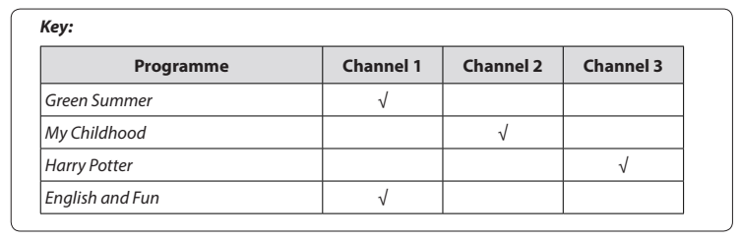
3. While-listening ( 15’)

ACTIVITY 2 : While-listening
Aim: To help Ss develop their listening skill for specific information.
* Content: Listen again to get specific information and tick T/F
* Output: Ss can tick T/F correctly through listening. Telling freely.
* Organisation : ..…

Teacher’s & Student’s activities | Content
2. Listen again and tick (✓) T (true) or F (False)  - This activity requires Ss to listen more carefully for details.  - Allow Ss some time to read the statements first and see if they can answer any of them based on the previous listening.  - Draw Ss' attention to the fact that almost all the questions start with the names of the programmes. They are signals that the answers are coming.  - Play the recording. Ss listen and tick.  - Check their answers as a class. If Ss have difficulty catching the information, determining their answers, pause the recording after each sentence where the information appears.  - Check and confirm the correct answers.  *Post-listening  * T may give some clues  - Call on some Ss to speak freely.  - Correct pronunciations, grammar, vocab, intonation. | 2. Listen again and tick (✓) T (true) or F (False)  - T_ Ss  - Listen to the teacher’s instructions carefully and learn how to do it.  - Fulfil the tasks  - Give the answers  Key:  1. T 2. F 3. T 4. F  Audio script:  Here are some interesting TV programmes for you. Green Summer, a music programme, is on channel 1. It starts at eight o'clock. My Childhood is on channel 2. It's the story of a country boy and his dog Billy. On channel 3, you will watch Harry Potter at 8.30. Children all over the world love this film. If you like to learn English, you can go to English and Fun on channel 1. It's at nine o'clock. We hope you can choose a programme for yourself. Enjoy and have a great time.
ACTIVITY 3 : Writing
Aim:To guide and prepare Ss with information for their writing in 4.
* Content: Read and circle the right answer to get information for the next writing
* Output: Ss read and choose the correct answer.
* Organisation : ..…

3. Read the questions and circle the right answers for yourself  - Ss have to answer a questionnaire about TV-watching habits.  - Let Ss read the questions and choose the most appropriate answers for themselves | 3. Read the questions and circle the right answers for yourself  - T_ Ss  - Listen carefully to the instructions  - Work individually  * Ss learn how to do the tasks  - Ss’ answers
4. PRODUCTION/ APPLLICATION (8’-10’)

ACTIVITY 4:
Aim:To guide Ss how to write a paragraph about TV-watching habits.
* Content: Write a paragraph about TV- viewing habits.
* Output: Ss can write a paragraph completely.
* Organisation : ..…

Teacher’s & Student’s activities | Content
4. Write a paragragh of about 50 words about your TV-riewing habits. Use your answer in 3.  - Have Ss work individually. Ask them to refer to the questions and their answers in 3 while they are writing. These questions are a very good guide of how to form a sentence and what information they need to complete the sentence.  - Go round and offer help if needed.  - If time allows, ask some Ss to share their writing with the class. If not, collect some Ss' writings to correct at home.  Note: Tell Ss that the information in the questions in 3 has been arranged in a logical order and they can organise their writing by referring to their answers one after another.  - Ask Ss to write the first draft individually.  * Post writing  - T may display all or some of the Ss' writings on the wall / notice board. T and other Ss give comments. Ss edit and revise their writing as homework.  - If time is limited,T may ask Ss to write the final version at home.  - Other Ss and T comment on the writing. | 4. Write a paragragh of about 50 words about your TV-riewing habits. Use your answer in 3.  - Listen carefully and learn how to write  - Work individually  - Write themselves  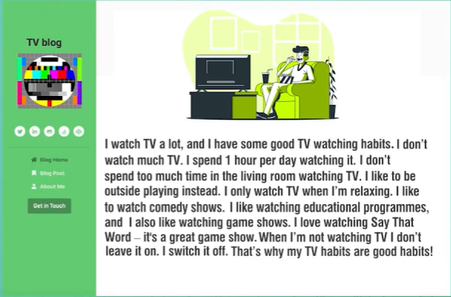  *Sample answer  I like watching TV, about one hour a day. I only watch TV in the evening. During the day, I go to school.  On Saturday and Sunday, I watch more. Sometimes I watch TV when I'm eating, but I never watch TV when I'm studying. I watch Science programme the most. It has interesting educational programmes for children.  * Write a short paragraph about your favourite TV programme.  My favourite TV programme is the game show: Children are Always Right on VTV 3 at 8.30 pm on Saturday. It tests your general knowledge about nature, science..... . I like this programme very much because it is useful, interesting, and exciting. I can learn many interesting facts about the nature, and the world.
5. WRAP-UP & HOME WORK (2’)
* Have Ss summarise what they have learnt with the two skills.
- T can instruct them to draw a mind map to summarise the main points of the lesson.
* HOME WORK.
- Finish writing a diary entry. Copy in the note books.
- Do more exercises in workbook.
- Prepare new lesson.
=========================

