UỶ BAN NHÂN DÂN HUYỆN THANH TRÌ
TRƯỜNG THCS THANH LIỆT

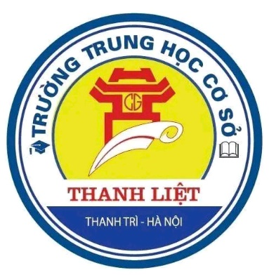

KẾ HOẠCH BÀI DẠY

DỰ THI GIÁO VIÊN DẠY GIỎI CẤP HUYỆN
TIẾNG ANH 7

UNIT 9: FESTIVALS AROUND THE WORLD
PERIOD 69: LESSON 1 – GETTING STARTED

Giáo viên thực hiện  Tổ | : Nguyễn Bích Ngọc  : Năng khiếu

NĂM HỌC 2024 -2025

Date of planning: 01/03/2025

UNIT 9: FESTIVALS AROUND THE WORLD

Period 69 - LESSON 1: GETTING STARTED

I. OBJECTIVES
By the end of this lesson, students will be able to gain:
1. Knowledge
- Get an overview about the topic “Festivals around the world”
- Use lexical items related to the topic “Festivals”: names of different festivals around the world
2. Core competence
- Develop communication skills
- Be collaborative and supportive in pair work and team work
- Actively join in class activities
3. Personal qualities
- Be benevolent and responsible.
- Raise students’awareness of festival around the world, especially in Viet Nam.
- Take pride in the love of homeland.
II. MATERIALS
- Grade 7 textbook, Unit 9, Getting started.
- Computer connected to the internet.
- TV/ pictures and cards
III. TEACHING WAYS
- Teacher - whole class, Students – Studentss, individual work, pair works, group works, team works
IV. TEACHING PROCEDURES
Teacher’s and students’ activities | Content
I. WARM UP & INTRODUCTION (5 minutes)
Aim: - To warm up the class and lead in the lesson.
- To set the context for the listening and reading part.
* Greetings and chatting  * Mini game: KIM’S GAME  - Ask students to work in 4 groups.  - Make sure if Ss know the rules.  - Have students play the game.  - Check the answers as a class (crosscheck)  + Teacher and students read aloud the festivals to check and congratulate the winner.  - Teacher asks students some questions about the festivals on the board and leads in the new lesson. | Game: KIM’S GAME:  *Answer keys:  1. Christmas  2. Thanksgiving  3. Tet  4. Mid-Autumn Festival  5. La Tomatina  6. Cheese rolling
II. PRESENTATION (12 minutes)
2. Aims: - To provide students with vocabulary.
- To help students well-prepared for the listening and reading tasks.
Task 1. Vocabulary teaching  - Teacher uses some techniques to elicit new words.  - Teacher encourages students to say out the words.  - Teacher asks students to repeat in chorus then indivdually. Ask Students to pay attention to the stress of the words.  - Teacher checks pronunciation. | 1. New words:  1. parade (n/v): /pəˈreɪd/: cuộc diễu hành/ diễu hành [video]  2. costume (n): /ˈkɒstjuːm/: trang phục [explanation]  3. feast (n): /fiːst/: bữa tiệc [synonym]  4. float (n): /fləʊt/: xe diễu hành [video]  5.fireworks display:
- Teacher writes the words on the board and asks students to copy down. | /ˈfɑɪərˌwɜrks dɪˈspleɪ/: màn trình diễn pháo hoa [video]  6. folk dance (n): /ˈfəʊkˌdɑːns/: điệu nhảy/múa dân gian [picture]
Task 2. Checking vocabulary: Write a word or phrase from the box under each picture (Activity 3 – P.93)  - Teacher leads in the exercise, checks if students know what they have to do.  - Teacher has students read the whole words/ phrases in chorus.  - Teacher asks students to work individually in 1 minute to write a given word/phrase under each picture.  - After 1 minute, teacher calls on some students to give the answers and check as a class. | 2. Write a word or phrase from the box under each picture (Activity 3 – P93)  *Answer keys:  1. parade  2. costumes  3. feast  4. float  5. fireworks display  6. folk dance
Task 3. Fill in each blank with a given word or phrase from 3. You may have to change the form of the word or phrase (Activity 4 – P93)  - Teacher leads in the exercise 4.  - Teacher asks students some questions to elicit and check if they know what they will do.  - Teacher reminds students to change the form of the word/phrase if it’s necessary.  - Teacher models the first sentence then asks students to work individually in 1 minute to find the correct answers.  - Teacher moves around, observes students, and encourages them to involve in the task.  - After 1 minute, teacher calls some students to give the answers and explain, teacher confirms the answers. | 3. Fill in each blank with a given word or phrase from 3. You may have to change the form of the word or phrase (Activity 4 – P93)  * Answer keys:  1. folk dances  2. fireworks display  3. feast  4. parades  5. floats (float)/ costumes
III. PRACTICE (15 minutes)
3. Aims: - To have students get to know the topic.
- To have students get specific information of the text.
- To help students practice listening and reading the conversation.
* Set the scene:  - Teacher shows a picture of Ms Hoa, Mark and Trang and Tulip festival and leads to the conversation by asking some questions.  Task 4. Listen and read (Activity 1 – P92)  - Teacher has students listen and read the  conversation individually.  - Teacher asks students to practise reading the conversation in groups of three in 2 minutes.  - Teacher moves around to help and take notes pronunciation mistakes.  - After 2 minutes, teacher calls on some groups to read out. Other students listen and give comments. | 4. Listen and read (Activity 1 – P92)
Task 5. Read the conversation again. Who did the following activities? Tick the correct column. Sometimes you need to tick both (Activity 2 – P93) | 5. Read the conversation again. Who did the following activities? Tick the correct column. Sometimes you need to tick both (Activity 2 – P93)
- Teacher tells students to read the conversation again and find the answers by themselves in 1 minute.  - After 1 minute, teacher asks students check as a class by playing a game.  Game: Lucky Festival.  - Teacher makes sure if students know how to play the game.  - Teacher and students check the answers and give the evidence. | * Answer keys:  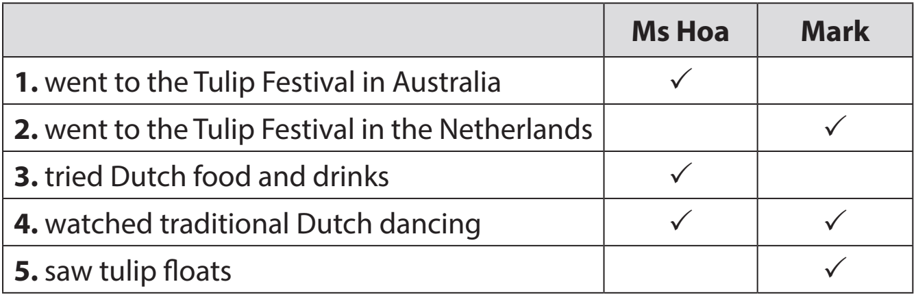
  1: (+1pts) | 2: (+3pt) | 3: (-1pt)
  4: (-2pts) | 5: (+3pts) | 6: Lucky (+5pt)
IV. PRODUCTION (11 minutes)
Aims: - To check Students’ knowledge of some familiar festivals.
Task 6. Talk about a festival you like best  - Teacher asks students to discuss in 4 groups in 3 minutes to talk about a festival they like best.  - After 3 minutes, the groups present their preparation.  - Teacher gives feedbacks. | 6. Talk about a festival you like best
V. WRAP-UP AND HOMEWORK (2 mins)
Aims: - To consolidate what students have learnt in the lesson.
- To give homework for students.
1. Wrap-up  - T asks Ss to wrap up what they have learned in the lesson by answering 2 questions individually.  - T confirms and correct. | * Wrap-up  1. Which festival is mentioned in the conversation (1. Listen and Read)?  A. Christmas.  B. A Tulip festival.  C. Halloween.  D. Cheese rolling.  2. Which word didn’t we learn in this lesson?  A. Float  B. Parade  C. Telephone  D. Fireworks display
2. Homework
- Revise the lesson.
- Do ex. B1,2,3 (WB).
- Prepare the next lesson: A closer look 1 (p.94)

