Week: 24
Period: 71

UNIT 9: WORLD ENGLISHES

Lesson 3: A closer look 2

I. OBJECTIVES

By the end of this lesson, Ss will be able to:

1. Knowledge

- Use defining relative clauses.

2. Competences

- Develop communication skills;

- Be collaborative and supportive in pair work and teamwork.

3. Personal qualities

- Develop self-study skills;

- Actively join in class activities.

II. MATERIALS

- Grade 9 textbook, Unit 9, A closer look 2

- Computer connected to the Internet

- Projector / TV

- hoclieu.vn

III. PROCEDURES

1. ACTIVITY 1: WARM-UP (7 mins)

a. Objectives:

- To create an active atmosphere in the class before the lesson;

- To lead students into the new unit.

b. Content:

- Brainstorming

c. Expected outcomes:

- Students can complete the sentence by using the structure of defining relative clauses.

d. Organisation:
TEACHER’S AND STUDENTS’ ACTIVITIES | CONTENTS
Brainstorming  -T writes the relative pronouns who, which, whose on the board and ask Ss the use of each as they learnt these pronouns in the previous unit.  - Ss look and answer.  - T writes part of this sentence on the board and ask Ss to complete it.  -Ss complete the sentence.  - T invites some Ss to share their answers. Quickly write some of their answers on the board. Confirm the correct ones.  - Ss share answers.  - T underlines the which-clause. Tell them that this clause is called a defining relative clause.  - Ss look and listen to the teacher’s explanation.  - T introduces the objectives of the lesson. T writes the objectives in the left corner of the board. | Example:  Part of the sentence:  English is the language which ________.

2. ACTIVITY 2: PRESENTATION (7 mins)

a. Objectives:

- To help students focus on the use of defining relative clauses.

b. Content:

- Grammar explanation

- Task 1: Choose the correct answer A, B, C, or D to complete each sentence.

c. Expected outcomes:

- Students know how to use defining relative clauses.

d. Organisation:
TEACHER’S AND STUDENTS’ ACTIVITIES | CONTENTS
- T has Ss read the two examples in the first Remember! box and pay attention to the bold words. Then tells them to read the information in the box.  - SS read the Remember! box carefully and listen to the teacher’s instruction.  - T checks their understanding by asking some questions.  - Ss listen and answer questions.  - T asks Ss to give some more examples. Comment on their examples.  - Ss give examples.  -T draws Ss’ attention to the second Remember! box. Write the two examples on the board and underline the parts of speech in each sentence.  - Ss look at the second Remember! box and listen to the teacher’s explanation.  - T tells Ss that when the relative pronoun is the object of the relative clause we can omit it and when it is the subject, we can’t.  - T shares with Ss a tip to identify when the relative pronoun is the subject or object: when there is a noun or pronoun between the relative pronoun and verb, the pronoun is the object.  - T refers back to the two examples in the first Remember! box and asks Ss if the relative pronoun in each example is the subject or object (1st example: subject; 2nd example: object). | 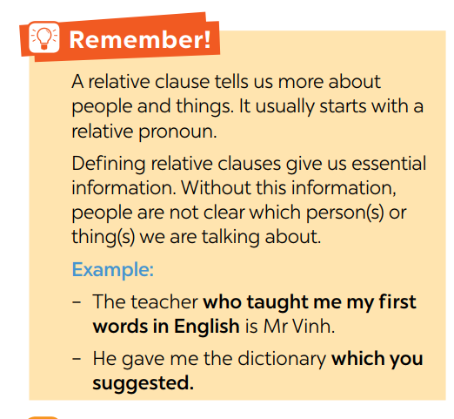  Questions:  + What is a relative clause?  + What does it usually start with?  + Why is a defining relative clause important?  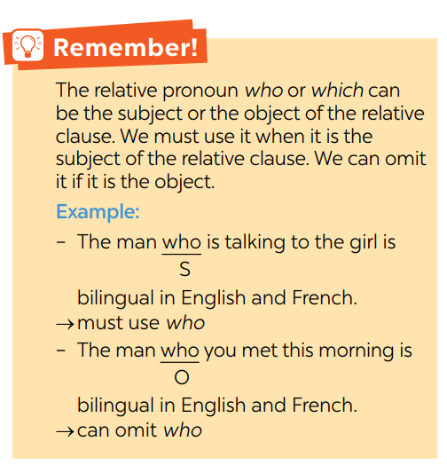
- T has Ss do the exercise individually and then checks their answers with a classmate.  - Ss do the task individually.  - T invites some Ss to share their answers. T confirms the correct answers.  - Ss share their answers.  - For a more able class,T asks Ss to decide if the relative pronoun in questions 1, 2, and 3 is the subject or object.  - Ss decide if the relative pronoun in questions 1, 2, and 3 is the subject or object. | Answer key:  1. B (subject)  2. A (subject)  3. B (subject)  4. C  5. D

3. ACTIVITY 3: PRACTICE (21 mins)

a. Objectives:

- To help students practise identifying if the relative pronoun is the subject or object;

- To practise further with defining relative clauses.

b. Content:

- Task 2: Underline the relative clause in each sentence. Decide if the relative pronoun is the subject (S) or object (O) of the relative clause and if we can or cannot omit it.

- Task 3: Are these sentences right or wrong? Correct them if necessary.

- Task 4: Combine the two sentences into one, using a relative pronoun.

c. Expected outcomes:

- Students can understand and use defining relative clauses.

d. Organisation:
TEACHER’S AND STUDENTS’ ACTIVITIES |  |  | CONTENTS

Task 2: Underline the relative clause in each sentence. Decide if the relative pronoun is the subject (S) or object (O) of the relative clause and if we can or cannot omit it. (6 mins)
- T models the way to do the exercise with the first sentence.  -T explains to Ss that first they need to identify the part of speech of the relative pronoun, and then decide to omit it or not.  1. The new vocabulary items which we learnt yesterday are difficult to remember. “ which: object” omit  - Ss follow the teacher’s instructions.  - T has Ss do this exercise individually and then compare their answers with a partner.  - Ss do the task individually.  - Ss compare answers.  - T asks some Ss to share their answers. Then T confirms the correct ones.  - SS check the answers. | Answer key:  - which we learnt yesterday (O - omit)  - which are in this book (S)  - who translated this novel into Vietnamese (S)  - who love languages (S)  - who we admire (O - omit)

Task 3: Are these sentences right or wrong? Correct them if necessary. (7 mins)
- T models with the first sentence if necessary. T writes it on the board and underline the mistake, and then corrects it.  My sister doesn’t like films have unhappy endings. which have  - Ss listen and follow the teacher’s instructions.  - T has Ss do this exercise individually and then compare the answers with another classmate.  - Ss do exercise individually.  - T checks the answers with the whole class. T confirms the correct ones.  - Ss check the answers. | Answer key:  1. have - which have  2. Correct  3. Correct  4. Correct  5. who - whose

Task 4: Combine the two sentences into one, using a relative pronoun. (13 mins)
- T models the first question, underlines the main noun in the first sentence and the word that refers to it in the second sentence. Then Tasks Ss what relative pronoun can replace the noun in the first |  | Answer key:  1. I met a woman whose husband is a famous linguist.  2. My friend's father who owns a travel  agency gave us the tickets.
sentence.  I met a woman. Her husband is a famous linguist. whose I met a woman whose husband is a famous linguist.  - Ss listen and follow the teacher’s instructions.  - T has Ss work in pairs to do the exercise.  - Ss work in pairs to do the task.  - T invites some Ss to write their answers on the board. T gives feedback and confirm the correct answers.  - Ss write answers on the board. Check the answers. |  |  | 3. The grammar exercise (which) nobody could do was very complicated.  4. I study English in a language school which is in the centre of the city.  5. The teacher praised the student who completed the quiz the fastest. / The student (who) the teacher praised completed the quiz the fastest.

4. ACTIVITY 4: PRODUCTION (7 mins)

a. Objectives:

- To practise further with defining relative clauses in a freer way.

b. Content:

- Task 5: Game: Clues for you. Work in two teams. A student from each team gives clues about an object or a person in class, using a relative clause. Students from the other team guess which object or person it is.

c. Expected outcomes:

- Students can practise more defining relative clauses.

d. Organisation:
TEACHER’S AND STUDENTS’ ACTIVITIES | CONTENTS
- T has Ss work in two teams. A student from each team gives clues about an object or a person in class, using relative clauses. Students from the other team guess which object or person it is.  - Ss give clues and other answers.  - Ss work in groups.  - T asks Ss to read the example carefully.  - Ss read examples first.  - Set a time limit of about 5-7 minutes. The person who gives clues can only give three clues at most. For each correct guess after the third clue, the guessing team can get one point. The team with more points is the winner.  -Ss play games.  EXTRA ACTIVITY  Relative clauses challenge  -T has Ss work in groups. T gives each group some words related to places, animals, things, etc. and asks them to write definitions of the words. T asks groups to read out their definitions and vote for the best one(s). Then tells them they can’t vote for their own definition.  - T models with a word. | Example:  Student A:  This is something which we write with.  Student from other team:  Is it a pen?  Student A:  Yes, it is.  Example:  bilingual (n)  -> Definition: A bilingual is a person who can speak two languages equally well.

5. ACTIVITY 5: CONSOLIDATION (3mins)

a. Wrap-up

- Summarise the main points of the lesson.

b. Homework

- Do exercises in the Workbook.

- Make 5 sentences using defining relative clauses.

----------------------------------------------------

