Week: 29
Period: 87

UNIT 11: SCIENCE AND TECHNOLOGY
Lesson 1: Getting started – Great news for students

I. OBJECTIVES: By the end of this lesson, students will be able to:
1. Knowledge
- Gain an overview about the topic “Science and technology”
- Gain vocabulary to talk about “Science and technology”
2. Competences
- Develop communication skills and creativity
- Be collaborative and supportive in pair work and teamwork
- Actively join in class activities
3. Personal qualities
- Students are more aware of development of “Science and technology”
II. MATERIALS:
- Grade 8 textbook, Unit 11: Getting started
- Computer connected to the Internet
- Projector/ TV/ pictures and cards
- hoclieu.vn
III. PROCEDURES:
ACTIVITY 1: WARM-UP (5’)
a. Aims:
- To create an active atmosphere in the class before the lesson;
- To review the previous unit;
- To lead into the new unit.
b. Content:
- Chitchatting: Look at the pictures and answer the questions.
c. Expected outcome:
- Having a chance to speak English and focus on the topic of the lesson.
d. Organization:
Teacher’s and Students’ activities | Content
* Warm-up: Chitchatting  - T has Ss to look at the pairs of pictures and talk  about it by answering the question: “What do you think of these pictures?”  - Ss work in pairs to do the task.  - T calls on some Ss to give their ideas about it.  - T listens, comments, then leads Ss to the new lesson.  - T says: “In the lesson today we are going to learn a new unit about Science and technology. Let’s start to see and find out more information related to our new topic”. | * Chitchatting: Look at the pictures and answer the questions  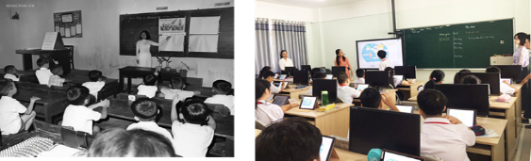  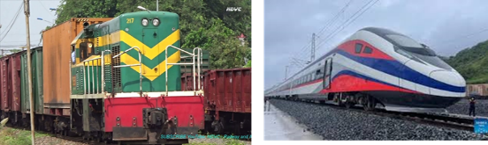  What do you think of these pictures?  => Talk about the development of science and technology.
ACTIVITY 2: PRESENTATION (7’)
Pre-teach vocabulary
a. Aims:
- To set the context for the introductory dialogue;
- To introduce the topic of the unit.
b. Content:
- Learn some new words. Read the conversation and find out new words.
c. Expected outcomes:
- Know more new words;
- Understanding the conversation and the topic of the lesson.
d. Organization:
Teacher’s and Students’ activities | Content
* Pre-teach vocabulary  - T introduces the vocabulary.  - T explains the meaning of the new vocabulary by pictures/ explanation/ examples.  - T reveals that these seven words will appear in the reading text and asks Ss to open their textbooks to discover further. | * Vocabulary  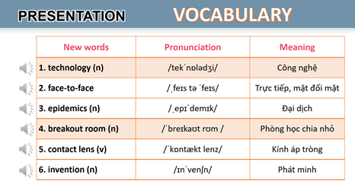
ACTIVITY 3: PRACTICE (23’)
Task 1 + Task 2 + Task 3 + Task 4
a. Aims:
- To help students read for specific information about the conversation;
- To help students learn words and phrases related to different modern technologies;
- To help students have more information about inventions.
b. Content:
- Task 1: Listen and read.
- Task 2: Read the conversation again and tick () T (True) or F (False).
- Task 3: Label each picture with a phrase from the box.
- Task 4: Complete the sentences, using the phrases in 3.
c. Expected outcome:
- Know more new words about different modern technologies and inventions, understand the conversation; topic of the lesson.
d. Organization:
Teacher’s and Students’ activities | Content
Task 1  * Set the context  - T has Ss to look at the pictures in the book and answer the questions.  - T encourages Ss to answer the questions, but doesn’t confirm their answers.  - T plays the recording for Ss to listen and read along. Then invite some pairs of Ss to read the conversation aloud.  - T refers to the questions previously asked and confirms the correct answer.  Task 2  - Ask Ss to work in pairs to read the conversation.  - Ask them to underline the keywords and phrases in the statements. Then, have pairs work for one or two minutes to check if the statements are true or false.  - Have Ss read out the statements and say if the statements are true or false.  - Make sure they pronounce the words correctly.  - Check the answers as a class.  Task 3  - Ask Ss to say the phrases aloud. Make sure they pronounce the phrases correctly.  - Ask Ss to work in pairs to label the pictures with the appropriate words or phrases.  - Check the answers as a class.  Task 4  - Ask Ss to work independently to complete each sentence with a phrase from the box in 3.  - Allow Ss to refer to the pictures and phrases in Task 3 or the conversation if needed.  - Check the answers as a class.  - Ask several Ss to read aloud the full sentences. Correct Ss’ pronunciation if needed. | Task 1: Listen and read.  * Questions:  - Who are the girl and the boy?  - Where do you think they are?  - What might they be talking about?  - What can you see in the bubble?  * Suggested answers:  - They are Minh and Ann.  - They are at school.  - They are discussing their online class/ robot teacher.  Task 2: Read the conversation again and tick () T (True) or F (False).  * Answer keys:  1. F  2. T  3. F  4. T  5. T  Task 3: Label each picture with a phrase  from the box.  * Answer keys:  1. computer screen  2. 3D contact lenses  3. online class  4. robot teacher  5. breakout rooms  6. Internet connection  Task 4: Complete the sentences, using the phrases in 3.  * Answer keys:  1. computer screen  2. breakout rooms  3. robot teacher  4. online class  5. 3D contact lenses
ACTIVITY 4: PRODUCTION (5’)
Task 5
a. Aims:
- To introduce some inventions;
- To create a fun atmosphere in the class.
b. Content:
- Task 5: Find out the things that were invented in the given years.
c. Expected outcome:
- Students can find out the things that were invented in the given years.
d. Organization:
Teacher’s and Students’ activities | Content
Task 5:  - Ask Ss to work in pairs to read the information and to make guesses.  - Encourage Ss to guess as many things as possible.  - Ask some Ss to report things they have thought of/ work out. | Task 5: Quiz: Do you know what things were invented in these years? Work in pairs and find out.
ACTIVITY 5: CONSOLIDATION (3’)
a. Aim:
- To consolidate what students have learned in the lesson.
b. Content:
- Talk about what they have learned in the lesson.
c. Expected outcome:
- Say aloud some words they remember from the lesson.
d. Organization:
Teacher’s and Students’ activities | Content
- T asks Ss to talk about what they have learned in the lesson.  - Ss work individually. | - Some new words.  - Read and understand the content of the conversation.
HOMEWORK (2’)
a. Aim:
- To revise the lesson and prepare for the next lesson.
b. Content:
- Review the lesson, prepare for the next lesson and do exercises in the workbook.
c. Expected outcome:
- Students’ textbooks and workbooks.
d. Organization:
Teacher’s and Students’ activities | Content
- T reminds Ss to do homework and prepare for the new lesson. | - Learn by heart all the new words.  - Do exercises in workbook.  - Prepare: Unit 11 – Lesson 2.

