UNIT 7: NATURAL WONDERS OF THE WORLD
Lesson 1: Getting Started – Meeting on the corridor

I. OBJECTIVES: By the end of this lesson, students will be able to:
1. Knowledge:
- Use the words related to the topic “Natural wonders of the world”
- Gain vocabulary to talk about natural wonders of the world
- To practice listening and reading skills
2. Competence:
- Students will be able to practice listening, speaking, reading and writing skills
- Develop communication skills and cultural awareness
- Be cooperative and supportive in pair work and teamwork
3. Personal qualities:
- Actively participate in class activities
- Develop self-study skills
II. TEACHING AIDS:
- Teacher: Grade 9 textbook; Projector / TV…
- Students: Textbooks, workbooks…
- Computer connected to the Internet
- Hoclieu.vn / Sachmem.vn
III. PROCEDURES:
WARM-UP & INTRODUCTION (3’ - 5’)
* Aims: To create an active atmosphere in the class before the lesson;
To lead into the new lesson.
* Content: Think!;
To have some warm-up activities to create a friendly and relaxed atmosphere to inspire students to warm up to the subject and new lesson.
* Expected outcomes: Students can answer some questions of the teacher about some cities;
Having a chance to speak English.
* Organization: Teacher’s instructions …
Teacher’s and Students’ activities | Content
* Greeting  * Option 1: Think!  - Begin the lesson by talking about the beauty around us. Ask Ss to identify/ talk about the most beautiful places in their own community.  - T introduces the topic Natural wonders of the world. Show Ss some photos of famous natural wonders, such as Ha Long Bay, Sahara Desert, Great Barrier Reef, ...  - Ask Ss to open their books.  - Draw their attention to the box and introduce what they are going to learn in this unit.  - T may introduce some warm-up activities to create a friendly and relaxed atmosphere to inspire Ss to warm up to the subject and new class.  - T encourages Ss to talk in English as much as possible.  - Write the unit title on the board. Ask Ss to open their books and start the lesson.  - Share with Ss the objectives of the lesson by displaying them on a projector. Alternatively, write the objectives in a corner of the board and leave them there and tick the objective off when the class finishes with them. | * Greeting:  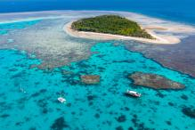    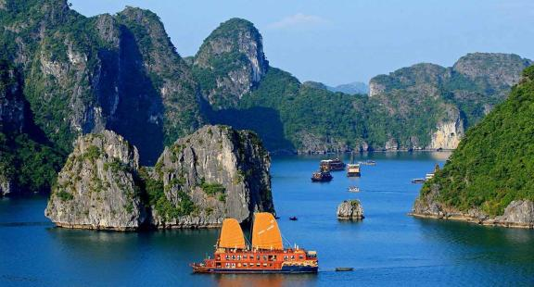
ACTIVITY 1: PRESENTATION/ NEW LESSON (12’ - 15’)
* Aims: To create an active atmosphere in the class before the lesson;
To lead students into the new unit.
* Content: Learn some new words;
Read the conversation and find out new words;
Focus on topic of the lesson, grammar points.
* Expected outcomes: Knowing more new words;
Understanding the conversation; topic of the lesson, grammar points.
* Organisation: Teacher’s instructions …
Teacher’s and Students’ activities | Content
Task 1: Listen and read.
* Teach vocabulary:  - T uses different techniques to teach vocabulary (situation, realia, translation).  - T introduces the vocabulary by:  + providing the pictures  + eliciting the definition of the words  * Checking vocab: Rub out and remember.  - To begin with, ask Ss some questions: Have you ever been to Ha Long Bay? Do you know that it is a famous natural wonder? Have you heard of/ read about other wonders: Mount Everest, the Dead Sea?, etc.  - Set the context for the listening and reading by asking Ss to look at the picture.  - Then ask Ss to look at the title and guess what the conversation between Lan and Tom is about.  - Play the recording for Ss to listen and read along.  - Then have some Ss read the conversation aloud.  - Ask Ss some questions about the conversation.  - Confirm the correct answer. (They are talking about famous natural wonders.)  - Have Ss say the words in the text that they think are related to the topic of the unit. | - * Vocabulary:  1. crazy (adj) about sb/sth /ˈkreɪzi/: thích mê  2. coral (n,adj) /ˈkɒrəl/:s san hô  3. landscape (n)/ˈlænd.skeɪp/ phong cảnh  4. peak (n) /piːk/ đỉnh, đỉnh núi  5. charming (adj) /ˈtʃɑː.mɪŋ/ đẹp  6. sustainable (adj) /səˈsteɪnəbl/ bền vững  7. location (n) /ləʊˈkeɪʃn/ địa điểm, nơi chốn  8. possess (v) /pəˈzes/ có, sở hữu  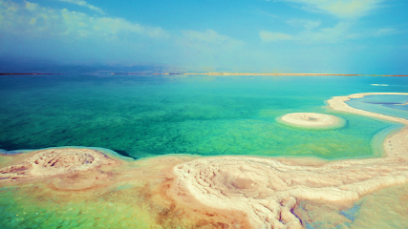
ACTIVITY 2: PRACTICE (15’)
* Aims: To help students understand the text;
To help students learn the new vocabulary of the unit;
To help students revise and learn the vocabulary related to the topic of the unit.

* Content: Task 2: Read the conversation again and tick (√) T (True) of F (False) for each sentence;

Task 3: Complete each sentence with a word or a phrase from the box;
Task 4: Underline the correct answer to complete each sentence.
* Expected outcome: Students understand the conversation and topic of the lesson and can complete the tasks successfully.
* Organisation: Teacher’s instructions …
Teacher’s and Students’ activities | Content
Task 2: Read the conversation again and tick (√) T (True) or F (False) for each sentence.
- Have Ss work individually. Tell them to read the statements and decide whether they are true (T) or false (F) without reading the conversation again.  - If Ss find the task difficult, ask them to read the conversation again and find the information in it.  - Check their answers and explain if necessary. | * Answer keys:  1. T  2. F  3. T  4. F
Task 3: Complete each sentence with a word or a phrase from the box.
- Ask Ss to read the sentences and find the words from the box to fill in the gaps.  - Have Ss share answers before discussing it as a class.  - Have some Ss write the correct answers on the board. If there's time, call on some Ss to read the sentences. | * Answer keys:  1. landscape  2. couldn’t help  3. explore  4. support  5. development
Task 4: Underline the correct answer to complete each sentence.
- Have Ss work independently. Ask them to read the sentences, paying attention to the words given in brackets and their collocations.  - Tell Ss that most of these words appear in the conversation, so they can look back and find the words.  - Have Ss share answers before discussing it as a class.  - For more able Ss, have them make up sentences with these words. | * Answer keys:  1. crazy  2. landscape  3. explore  4. suggest  5. contributes
ACTIVITY 3: PRODUCTION/ FURTHER PRACTICE (8’)
* Aim: To help students learn about some famous natural wonders of the world.
* Content: Task 5: Game: Natural Wonders Knowledge.
* Expected outcome: Students can know more about Natural Wonders.

* Organisation: Teacher’s instructions …
Teacher’s and Students’ activities | Content
Task 5: Game: Natural Wonders Knowledge.
- Ss work in groups of three or four. Explain to them what they are going to do.  - Give Ss some time (3-4 minutes) to do the task.  - T may call on some groups to write their answers on the board.  - The group that has the most correct answers wins. | * Suggested answers:  - The Grand Canyon, USA  - The Great Barrier Reef, Australia  - Ha Long Bay, Vietnam  - Northern Lights, Arctic and Antartic.
WRAP-UP & HOMEWORK (2’)
- Ask one or two Ss to tell the class what they have learnt.
- Ask Ss to say aloud some words/ phrases and the grammar points they remember from the lesson. Tell Ss that they will learn these language points in the upcoming lessons.
Notes: Mount Everest: the highest mountain in the world (8,849m), located on the border between China and Nepal.
* HOMEWORK:
- Do more exercises in workbook.
- Prepare new lesson: Lesson 2: A CLOSER LOOK 1.

