ĐỀ SỐ 24
Mark the letter A, B, C, or D on your answer sheet to indicate the word whose underlined part differs from the other three in pronunciation in each of the following questions.
Question 1. A. sign B. shift C. gift D. king
Question 2. A. feature B. culture C. tradition D. statue
Mark the letter A, B, C, or D on your answer sheet to indicate the word that differs from the other three in the position of primary stress in each of the following questions.
Question 3. A. intend B. install C. follow D. decide
Question 4. A. humorous B. essential C. dangerous D. regular
Mark the letter A, B, C, or D on your answer sheet to indicate the correct answer to each of the following questions.
Question 5. The kids were still playing football ______ the heavy rain.
A. despite B. in spite C. although D. because of
Question 6. She was ______ that she always came top of the class.
A. so clever B. too clever C. such clever D. clever enough
Question 7. Do you mind if I turn ______ the TV? I want to watch the news.
A. off B. out C. down D. on
Question 8. You don’t seem very ______ in the movie. Don’t you like it?
A. interested B. interesting C. interest D. interestingly
Question 9. If the weather ______ worse, we won’t go to the beach.
A. gets B. will get C. got D. would get
Question 10. English is his ______ tongue. Besides, he can speak French and Spanish.
A. mother B. language C. country D. nation
Question 11. My sister will ______ my children when I am on business.
A. go down B. get off C. turn on D. look after
Question 12. Mrs. White: “Thank you very much for helping the disadvantaged children here!”
The volunteers: “______”
A. What a pity! B. It’s our pleasure.
C. Sorry, we don’t know D. That’s nice of you.
Read the following announcement and mark the letter A, B, C, or D on your answer sheet to indicate the correct option that best fits each of the numbered blanks from 13 to 16.
Good evening, ladies and gentlemen. We have (13) ______ at JFK airport (14) ______ New York, where the local time is 18:30 and the temperature is 76°. We hope you (15) ______ your flight with American Airlines this evening (16) ______ wish you a very safe journey to your final destination.
Question 13. A. departed B. taken off C. reached D. landed
Question 14. A. in B. at C. on D. into
Question 15. enjoyed B. have enjoyed C. will enjoy D. enjoy
Question 16. A. so B. but C. and D. nor
Question 17. Put the sentences (a-c) in the correct order, then fill in the blank to make a logical text.
I was nervous about my first day at a new school. ______
a. My classmates were friendly and welcoming, making me feel comfortable in no time.
b. I was worried about meeting new people and making friends in a completely unfamiliar environment.
c. To my surprise, the day turned out to be much better than I expected.
A. b-c-a B. c-a-b C. a-b-c D. b-a-c
Question 18. Choose the sentence that can end the text (in Question 17) most appropriately.
A. I quickly realized that starting a new school can be exciting and full of new opportunities.
B. I made sure to put a smile on my face, and it made a difference in how others interacted with me.
C. The teachers were kind and helpful, making the transition much easier.
D. The first day was definitely challenging, but I learned to adapt and overcome my fears.
Read the following passage and mark the letter A, B, C, or D on your answer sheet to indicate the correct word or phrase that best fits each of the numbered blanks from 19 to 24.
What makes a good language learner?
- Don't be afraid of making mistakes. Good language learners notice their mistakes and learn from (19) ______.
- Do group activities. A good language learner always (20) ______ opportunities to have a talk with other students.
- Make notes during every class. Notes help you (21) ______ new language. Look at your notes when you do your homework.
- Use a dictionary. Good language learners often use dictionaries to (22) ______ words they don't know. They also make their own vocabulary lists.
- Do extra practice. Test and improve your language, reading and listening skills with self-study materials. You (23) ______ find a lot of them online.
- Enjoy learning. Watch a TV series or films, listen to songs, play video games (24) ______ read books in the language you are learning. It's never too late to become a good language learner.
Question 19. A. her B. him C. you D. them
Question 20. A. looks at B. looks for C. picks up D. turns down
Question 21. A. to remember B. remembering C. remembered D. to remembering
Question 22. A. look B. support C. lose D. check
Question 23. A. must B. should C. may D. can
Question 24. A. and B. so C. or D. but
Mark the letter A, B, C or D on your answer sheet to indicate the sentence that is closest in meaning to the original sentence in each of the following questions.
Question 25. “If I were you, I would take a break,” Tom said to Daisy.
A. Tom wanted to take a break with Daisy.
B. Tom advised Daisy to take a break.
C. Tom suggested not taking a break.
D. Tom offered Daisy to take a break.
Question 26. We broke the computer. It belongs to my father.
A. We broke the computer which it belongs to my father.
B. We broke the computer who belongs to my father.
C. We broke the computer which belongs to my father.
D. We broke the computer, that belongs to my father.
Mark the letter A, B, C, or D on your answer sheet to indicate the sentence that is made from the given cues in each of the following questions.
Question 27. I / have / an / exciting / holiday / before.
A. I have had such an exciting holiday before.
B. I have never have such an exciting holiday before.
C. I never had such an exciting holiday before.
D. I have never had such an exciting holiday before.
Question 28. It / difficult I exercise / we / could / not / do / it.
A. It was so a difficult exercise that we couldn’t do it.
B. It was too a difficult exercise that we couldn’t do it.
C. It was such difficult exercise that we couldn’t do it.
D. It was such a difficult exercise that we couldn’t do it.
Read the following sign or notice and mark the letter A, B, C, or D on your answer sheet to indicate the correct answer to each of the following questions.
Question 29. What does the sign say?
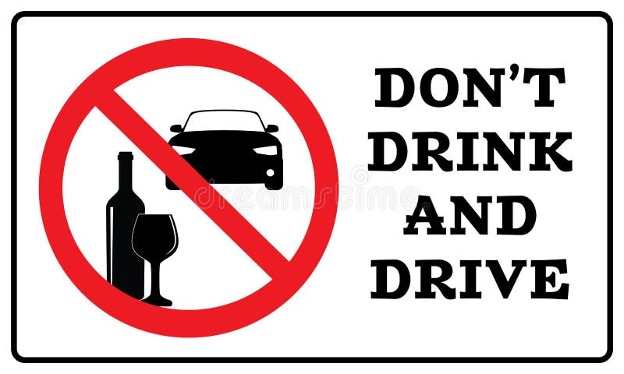
A. Drinking alcohol is not safe when you are driving a car or other vehicles.
B. You can drive a car if you drink only a little alcohol and feel okay.
C. It is good to drink water while driving so you stay awake and safe.
D. You should only drive if you have not had any alcohol to drink.
Question 30. What does the notice say?
“Attention, all students! Please note that our library will
now open at 10:00 AM and close at 6:00 PM, Monday through Friday.
Our weekend hours remain the same. Thank you for your cooperation.”

A. Change in the library’s hours on weekends.
B. Change in the library’s location.
C. Change in the library’s opening and closing times on weekdays.
D. Change in the library’s phone number.
Read the following passage and mark the letter A, B, C, or D on your answer sheet to indicate the correct answer to each of the following questions from 31 to 36.
Some doctors think that you should drink a glass of water each morning because of its importance to your body. You should drink this water first thing before doing anything else. The temperature of the water should be similar to body temperature; neither too hot nor too cold.
Water helps clean out your kidneys. It prepares your stomach for digestion. Water can also help your intestines work better. After drinking water, the intestines can more easily take out nutrients from our food. Water also helps us go to the bathroom more easily.
Scientists suggest that people take in 1,600 millilitres of water each day. However, don't drink all of that water in one sitting. If you do, your kidneys will have to work much harder to eliminate it. It's better to drink some in the morning and some in the afternoon. Some people think it's better to drink between meals and not during meals. They think water dilutes the juices produced in our stomachs. This can interfere with I normal digestion.
Question 31. The reason why people ought to drink water every morning is that.
A. it is important to the body
B. its temperature is similar to body temperature
C. it is the first thing to do before doing anything else
D. it helps us avoid being thirsty
Question 32. Which of the following is NOT mentioned in paragraph 2 as the part of the body that water is good for?
A. kidneys B. stomach C. livers D. intestines
Question 33. Scientists suggest that people drink ______ of water each day.
A. 16 millilitres B. 16000 millilitres
C. 160 millilitres D. 1600 millilitres
Question 34. The word “take in” in paragraph 3 is CLOSEST in meaning to ______.
A. consume B. save C. use D. collect
Question 35. The word “eliminate” in paragraph 3 is OPPOSITE in meaning to ______.
A. remove B. delete C. process D. keep
Question 36. What is the main idea of the passage?
A. The best amount of water to drink B. The importance of water
C. How to drink water properly D. The advice for the doctors
Four phrases/ sentences have been removed from the text below. For each question, mark the letter A, B, C, or D on your answer sheet to indicate the correct option that best fits each of the numbered blanks from 37 to 40.
Some teenagers enjoy spending free time with their friends. Others prefer doing leisure activities with their family members. I love spending time with my family (37) ______.
At the weekend, we usually go for a bike ride. (38) ______. We take photos and look at them later. My big brother and I are also into cooking. My brother looks for easy recipes. After that, we prepare the ingredients and cook. Sometimes the food is good, but sometimes it isn't (39) ______. The leisure activity I like the most is doing DIY projects with my mum. She teaches me to make my own dresses and doll clothes. (40) ______. Once I won the first prize in a costume contest at my school.
A. We cycle to some nearby villages to enjoy the fresh air
B. On special occasions, we make special dresses together
C. because it's a great way to connect with them
D. nevertheless, we love whatever we cook
Question 37. __________ Question 38. __________
Question 39. __________ Question 40. __________

