ĐỀ SỐ 27
Mark the letter A, B, C, or D on your answer sheet to indicate the word whose underlined part differs from the other three in pronunciation in each of the following questions.
Question 1. A. mood B. tool C. flood D. soon
Question 2. A. warm B. wrong C. weak D. wide
Mark the letter A, B, C, or D on your answer sheet to indicate the word that differs from the other three in the position of primary stress in each of the following questions.
Question 3. A. explore B. follow C. install D. invest
Question 4. A. electric B. computer C. fascinate D. fantastic
Mark the letter A, B, C, or D on your answer sheet to indicate the correct answer to each of the following questions.
Question 5. How ______ does it cost you to buy a ticket for this concert?
A. many B. often C. long D. much
Question 6. Some students in my class would like ______ sports.
A. played B. playing C. play D. to play
Question 7. John told me to wait for him ______ the coffee shop.
A. in B. at C. on D. of
Question 8. This is the first time I ______ volunteer work in our community.
A. have done B. do C. would do D. did
Question 9. Jack is not ______ Linda because she always has the quickest answers.
A. as intelligent than B. more intelligent as
C. the most intelligent D. as intelligent as
Question 10. Sam is ______ young to live alone aboard.
A. too B. enough C. so D. such
Question 11. You ______ cut down on fast food, or else you will get fat quickly.
A. should B. can C. must D. may
Question 12. Jacob is talking to Rosie after the Spanish speaking contest.
Jacob: “Congratulations on winning the first prize!” - Rosie: “______”
A. What can I do for you? B. What a pity!
C. You’re welcome. D. Thank you so much.
Read the following announcement and mark the letter A, B, C, or D on your answer sheet to indicate the correct option that best fits each of the numbered blanks from 13 to 16.
Hi Sunny!
How are you?
We (13) ______ to Singapore, so I wanted to ask your advice on what we should do (14) ______ we're there. What shouldn't we miss? We’ll have our two kids aged 6 and 8 with us, so ideally we want to do things we can enjoy as a family.
We've already got a hotel booked in Marina Bay, and we arrive (15) ______ 12 May for a week.
I hope you're around, so we can (16) ______!
See you soon,
Janet
Question 13. A. will come B. come C. have just come D. are coming
Question 14. A. while B. during C. as D. when
Question 15. A. at B. in C. on D. about
Question 16. A. see in B. meet up C. turn up D. get over
Question 17. Put the sentences (a-c) in the correct order, then fill in the blank to make a logical text.
I was so excited to go to the amusement park with my friends. ______
a. We rode the roller coasters, went on the Ferris wheel, and played games in the arcade.
b. The park was crowded with people, but we still had a blast.
c. We arrived at the park and were greeted by the sights and sounds of excitement and laughter.
A. a-b-c B. b-a-c C. c-a-b D. c-b-a
Question 18. Choose the sentence that can end the text (in Question 17) most appropriately.
A. We ate delicious snacks like cotton candy and popcorn, and drank refreshing lemonade.
B. We even won a giant stuffed animal at the shooting game, which made me so happy!
C. We laughed and screamed with joy as we rode the thrilling rides.
D. The amusement park was definitely a great place to have fun and let loose.
Read the following passage and mark the letter A, B, C, or D on your answer sheet to indicate the correct word or phrase that best fits each of the numbered blanks from 19 to 24.
Britain will soon ban smoking in cars with children. Britain's government wants (19) ______ the harm cigarette smoke does to children. New laws will cut the chances of children passive smoking. This is when someone breathes in the smoke from other people's cigarettes. Many studies say passive smoking can almost be as (20) ______ as actually smoking a cigarette. The British government says that it has looked at searches pointing out that children (21) ______ sit in smoke-filled cars have health problems. It is particularly bad in cars because there is so little space, so the car fills (22) ______ smoke very quickly. Everyone agrees with the new law. Some lawmakers argue that it takes away the freedom for people to smoke in their own car. (23) ______, Britain's health minister states that the health of children is (24) ______ than the freedom to smoke.
Question 19. A. reduce B. to reducing C. to reduce D. reducing
Question 20. A. harmful B. heavy C. harmless D. careless
Question 21. A. whom B. who C. where D. when
Question 22. A. about B. of C. in D. with
Question 23. A. Moreover B. However C. Thus D. But
Question 24. A. as important as B. important
C. most important D. more important
Mark the letter A, B, C or D on your answer sheet to indicate the sentence that is closest in meaning to the original sentence in each of the following questions.
Question 25. It rained heavily. The match was cancelled.
A. Because the heavy rain, the match was cancelled.
B. In spite of the heavy rain, the match was cancelled.
C. Because of raining heavily, the match was cancelled.
D. Although it rained heavily, the match was cancelled.
Question 26. Michael is not tall. He cannot become a pilot.
A. Michael is tall enough to become a pilot.
B. Michael is not short enough to become a pilot.
C. Michael is so short to become a pilot.
D. Michael is not tall enough to become a pilot
Mark the letter A, B, C, or D on your answer sheet to indicate the sentence that is made from the given cues in each of the following questions.
Question 27. I / look / forward / travel / Nha Trang / next week.
A. I’m looking forward to travel to Nha Trang next week.
B. I’m looking forward travel to Nha Trang next week.
C. I’m looking forward to travelling to Nha Trang next week.
D. I’m looking forward travelled to Nha Trang next week.
Question 28. He / not / drive / carefully / he / use to.
A. He doesn’t drive as carefully as he used to.
B. He doesn’t drive carefully than he used to.
C. He doesn’t drive as carefully than he used to.
D. He doesn’t drive as carefully he does.
Read the following sign or notice and mark the letter A, B, C, or D on your answer sheet to indicate the correct answer to each of the following questions.
Question 29. What does the sign say?
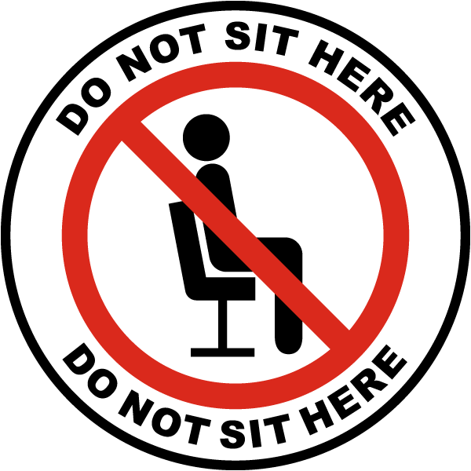
A. You can sit on the furniture if you want.
B. Only some pieces of furniture can be used for sitting.
C. Sitting on the furniture is not allowed here.
D. You may sit on the furniture only during designated breaks.
Question 30. What does the notice say?
Remember to switch off the lights when you leave.

A. Keep the lights on until someone tells you otherwise.
B. Leave the lights on for safety.
C. Only switch off the lights at night.
D. Turn off the lights before you go.
Read the following passage and mark the letter A, B, C, or D on your answer sheet to indicate the correct answer to each of the following questions from 31 to 36.
In the early years of television, educational specialists believed that it would be very useful in teaching and learning. Many schools have brought television sets, intending to use them effectively to improve the quality of education; but actually they are rarely used i properly in classrooms. Meanwhile, children spending the majority of their out-of-school ' hours watching TV and their typical school days proceed as if television did not exist.
There are some explanations for the failure of television to get the interest of the teachers. Firstly, the schools that purchased television sets have not set aside money for 2 equipment repairs and maintenance so these television sets are sooner and later out of work. Secondly, these schools have not found an effective way to train teachers to integrate television into their ongoing instructional programs. Lastly, most teachers do not regard the quality of television and its usefulness in the classroom.
Teachers at the schools work hard for at least twelve years to train their students to become good readers. However, according to recent statistics, teenagers seldom spend their free time reading books and newspapers but watching television instead.
Question 31. The text is about.
A. the use of television at schools B. teaching and learning television
C. educational specialists D. watching TV outside school
Question 32. The word “useful” in the first paragraph is OPPOSITE in meaning to ______.
A. helpful B. suitable C. effective D. harmful
Question 33. When TV first appeared, educational specialists ______.
A. did not appreciate it
B. did not appreciate it
C. believed it would be useful for schooling
D. banned children from watching TV
Question 34. Which of the following is NOT TRUE according to the passage?
A. Schools have brought television sets with the aim of improving the quality of education.
B. Television sets are used properly in classrooms.
C. Schools haven’t found an effective way to train teachers to integrate television into their ongoing instructional programs.
D. Television sets require repairs and maintenance.
Question 35. The word “out of work” in the first paragraph is CLOSEST in meaning to ______.
A. fix B. stop running C. unemployed D. energetic
Question 36. Children spend their free time.
A. reading books B. reading newspapers
C. learning foreign language D. watching TV
Four phrases/ sentences have been removed from the text below. For each question, mark the letter A, B, C, or D on your answer sheet to indicate the correct option that best fits each of the numbered blanks from 37 to 40.
The latest smartphones are sleek, slim, and offer many features such as high- resolution cameras, fast processors, and artificial intelligence capabilities. They allow users to perform a wide range of tasks, including browsing the Internet, (37) ______, and streaming videos.
(38) ______, They have unique features such as foldable screens, holographic displays, and improved battery life. Al will play a significant role in the development of these devices, (39) ______, facial recognition, and natural language processing becoming more sophisticated. (40) ______. They have abilities to control more of our daily activities, such as managing our homes, vehicles, and health. The possibilities are endless, and it will be exciting to see what the future holds for electronic devices.
A. In the future, smartphones are likely to become even more advanced
B. with features such as voice recognition
C. Smartphones will likely become even more integrated into our lives
D. sending emails, making video calls, playing games
Question 37. __________ Question 38. __________
Question 39. __________ Question 40. __________

