Week 25 Date of planning: ....../....../.........
Period 74 Date of teaching: ....../....../.........

UNIT 9: FESTIVALS AROUND THE WORLD

Lesson 6: Skills 2
I. OBJECTIVES:
By the end of this lesson, Ss will be able to gain:
- Listen for special information about a festival
- Write an email to describe a festival
1. Knowledge:
a. Vocabulary: types of festivals, festival activities
b. Grammar: review
2. Core competence:
- Develop communication skills and creativity
- Be collaborative and supportive in pair work and teamwork
- Actively join in class activities
3. Personal qualities
- Develop self-study skills
II. MATERIALS
1. Textbooks, plan
2. Equipment: computer accessed to the Internet, projector, loudspeaker
3. sachmem.vn
III. PROCEDURES : (STAGES)
Activity 1: Warm –up (5’)
* Aim: -To create an active atmosphere in the class before the lesson;
-To lead into the new lesson.
* Content: * Game: Bingo! - the names of some festivals
* Products: The student who has 3 words highlighted in a row yells “Bingo” and wins.
* Organization of implementation:
Teacher’s and Ss’activities |  |  | Content
GAME:  * Teacher tells the rules of the game:  Each student gets a piece of paper, draws a table with 3 rows and 3 columns, then fill in the table with names of some festivals randomly.  Teacher calls out the names of some festivals. Each time the teacher calls out a word, the students search for the right square on their paper and mark.  The student who has 3 words highlighted in a row yells “Bingo” and wins.  ** Students play the game in individuals  *** Teacher and students discuss the answers.  **** Teacher confirms the answers and gives feedback. |  |  | * Game: Bingo!  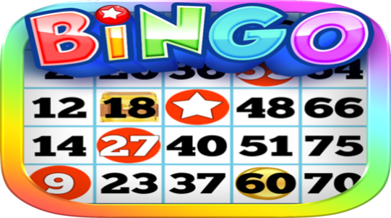
Activity 2: LISTENING
*Pre-Listening (5’)
Task 1
* Aim: To prepare Ss for the listening text.
* Content: Look at the animal. Discuss the questions with a partner.
* Products: Students discuss and give their answers.
* Organization of implementation:
Teacher’s and Ss’activities | Content
Task 1  * Teacher asks students to work in pairs, read the questions and answer.  ** Students quickly discuss with a partner.  *** Teacher allows Ss to cross check.  **** Teacher calls some Ss to give their answer on the board and elicits their answers. | Task 1: Look at the animal. Discuss the questions with a partner.  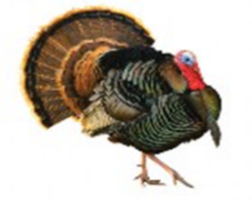  1. What is it?  2. What festival is it a part of?
* While -listening ( 10’)
Task 2
* Aims: To help Ss check their answer in Task 1.
* Content: Listen to Mark talking about how his family celebrates a festival. Check your answers.
* Products: Students listen and check their answers.
* Organization of implementation:
Teacher’s and Ss’activities |  | Content
Task 2  * Teacher tells Ss what they are going to listen to and plays the recording.  ** Students listen and check their answers.  *** Teacher allows students to peer check first.  **** Teacher confirms the answers and gives feedback. |  | Task 2: Listen to Mark talking about how his family celebrates a festival. Check your answers.  * Answer key:  1. A turkey  2. Thanksgiving
Task 3
* Aims: To help students develop listening skill for specific information (gap-filling).
* Content: Listening again and decide whether the following statements are true or false.
* Products: Students give the answers to the class and correct the mistakes
* Organization of implementation:
Teacher’s and Ss’activities |  | Content
Task 3  * Teacher asks students to read through the statements, have a guess before they listen to the recording the second time and write their guesses on the board.  ** Teacher plays the recording again. Ask students to listen and choose the correct answer.  *** Teacher lets students peer-check with a partner.  **** Teacher calls some students to give the answers to the class and correct the mistakes where necessary, encourages students to correct the false statements. |  | Task 3: Listening again and decide whether the following statements are true or false.  * Answer key:  1. F 2. F 3. T 4. F 5. T 6. T  Audio Script:  Hello everyone. I’m Mark. Today I’m going to talk about Thanksgiving, or Turkey Day. It’s a national holiday. People from Canada and the USA celebrate it every year to be thankful for successful harvests. In the USA, we celebrate it on the fourth Thursday of November. We usually prepare a feast for family and friends. Both adults and children take part in the food preparation. Some of the traditional foods are turkey, sweet potatoes, and cornbread. After the meal, we play board games together. My family usually takes this opportunity to help others. My parents volunteer to cook and serve food to homeless people. My sister and I read books to old people in a nursing home near our house.
Activity 3: WRITING
* Pre-Writing (5’)
Task 4
* Aims: To brainstorm ideas and make an outline for Ss’ writing.
* Content: Think about a festival that your family usually celebrates. Fill in the blanks with your answers
* Products: Ss complete the mind map on the group board.
* Organization of implementation:
Teacher’s and Ss’activities |  | Content
Task 4  * Teacher asks students to work individually to complete the mind map.  ** Students in individuals and decide on their festival.  *** Teacher goes around and helps if needed.  **** Teacher calls some Ss to give their answer (if time allows) and gives feedback. |  | Task 4: Think about a festival that your family usually celebrates. Fill in the blanks with your answers.  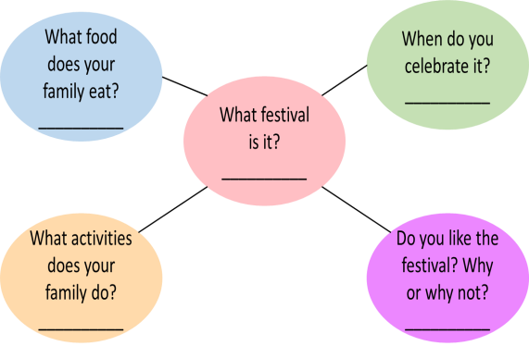
* While-Writing (5’)
Task 5
* Aim: To practise how to write a paragraph about a festival
* Content: Write an email of about 70 words to tell Mark about the festival.
* Products: Students’ writing and cross check. (individual work)
* Organization of implementation:
Teacher’s and Ss’activities |  | Content
Task 5  * Teacher shows a model of a short paragraph about a festival (T may use the audio script or reading passage-page 97). Then recalls students’ knowledge on the structure of an email.  ** T has Ss write their email in individuals based on the information in 4.  *** Teacher allows students to cross check first.  **** Teacher gives feedback. |  | Task 5: Write an email of about 70 words to tell Mark about the festival. Use the notes in 4.  Dear Mark,  How are you? I’m going to tell you about Mid Autumn Festival. It takes place in the middle of the eighth lunar month. My family and I often eat moon cakes, autumn fruits and watch lion dances. I like the festival very much because it was funny and meaningful.  I hope one day you can join the festival with us.  Cheers,
Activity 4: Post-Writing (2’)
* Aim: To peer check, cross check and final check students’ writing
* Content: Cross check students’ writing
* Products: Students’ writing on the posters.
* Organization of implementation:
Teacher’s and Ss’activities |  | Content
* Teacher asks students read their “production”.  ** Students listen to each other’s work.  *** Students then give comments to each other.  **** Teacher then gives feedback as a class discussion. |  | Task 6:  Class gallery  Giving peer-reflection & evaluation
Activity 5:Consolidation (2’)
* Aim: To consolidate what students have learnt in the lesson.
* Content: summarize the content of the lesson.
* Products: A student says what she/ he has learnt in the lesson.
* Organization of implementation:
Teacher’s and Ss’ activities |  | Content
- Teacher asks students to talk about what they have learnt in the lesson. |  | - listen for special information about a festival  - write an email to describe a festival.
* Homework (1’)
* Aim: To revise the knowledge that students have gained in this lesson.
* Content: Review the lesson and prepare for the next lesson and do exersie in the workbbook
* Products: Students’ textbook and workbook
* Organization of implementation
Teacher’s and Ss’ activities |  | Content
- Teacher asks students to rewrite their writing in their books.  - Teacher asks students to prepare the new lesson. |  | - Rewrite the writing in the notebook.  - Prepare “ Looking back and project”
*- Evaluation: ……………………………………………………………………………………………………………………………………………………………………………………

