Week 25 Date of planning: ....../....../.........
Period 75 Date of teaching: ....../....../.........

UNIT 9: FESTIVALS AROUND THE WORLD

Lesson 7: Looking back and project
I. OBJECTIVES:
By the end of this lesson, Ss will be able to gain:
1. Knowledge
Review the vocabulary and grammar of Unit 9
Apply what they have learnt (vocabulary and grammar) into practice through a project
2. Core competence
- Develop communication skills and creativity
- Develop presentation skill
- Develop critical thinking skill
- Be collaborative and supportive in pair work and team work
- Actively join in class activities
3. Personal qualities
- Be more creative when doing the project
- Develop self-study skills
II. MATERIALS
- Grade 7 textbook, Unit 9, Looking back & Project
- Computer connected to the internet, Pictures, A0 paper
- Projector/ TV
- sachmem.vn

III. PROCEDURES : (STAGES)
Activity 1: Warm-up (5’)
* Aim: - To revise the vocabulary related to the topic and lead in the next part of the lesson.
- To enhance students’ skills of cooperating with team mates.
* Content: Write the names of the festivals
* Products: The group having more correct answers is the winner.(posters).
* Organization of implementation:
Teacher’s and Ss’activities |  |  | Content
Warm up  * Teacher divides the board, and divides the class into 2 teams.  ** Members of each team take turns and write as many types of festivals as possible in 2 minutes.  *** Students cross check their answers first.  **** Teacher confirms the answers and gives feedback. The group having more correct answers is the winner. |  |  | 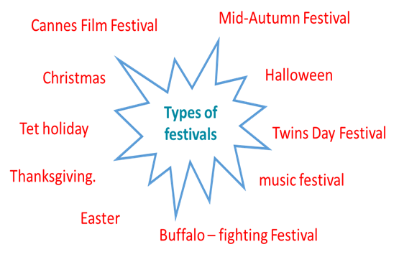
Activity 2 : VOCABULARY (12’)
Task 1 + Task 2
* Aim: To help students revise vocabulary items they have learnt in the Unit.
* Content: Circle the correct words or phrases in brackets.
Complete each sentence by filling in the blank with a word or phrase in the box.
* Products: Students say the correct key aloud ( individual work).
* Organization of implementation:
Teacher’s and Ss’activities | Content
Task 1  * Teacher encourages students to complete the task individually.  ** Students do the task individually.  *** Students exchange their textbooks with their partners.  **** Teacher gives feedback as a class discussion.  Task 2  * Teacher encourages students to complete the task individually.  ** Students do the task individually.  *** Students exchange their textbooks with their partners.  **** Teacher gives feedback as a class discussion. | Task 1: Circle the correct words or phrases in brackets.  * Answer key:  1. fireworks  2. Cannes Film Festival  3. painting  4. candy apples  5. Thanksgiving  Task 2: Complete each sentence by filling in the blank with a word or phrase in the box (p.100).  * Answer key:  1. lion dances  2. floats  3. costumes  4. Bunny  5. gathering
Activity 3: GRAMMAR (13’)Task 3 + Task 4
* Aims: To help students revise Yes/No questions.
* Content: Choose the correct question A or B ; Answer the following questions about yourself.
* Products: Ss read aloud their answers.
* Organization of implementation:
Teacher’s and Ss’activities |  | Content
Task 3  * Teacher encourages students to complete the task individually.  ** Students do the task individually.  *** Students exchange their textbooks with their partners.  **** Teacher calls some Ss to read aloud their answers and gives feedback.  Task 4* Teacher encourages students to complete the task individually.  ** Students do the task individually.  *** Students share their answer in groups of 3 of 4.  **** Teacher calls some Ss to read aloud their answers and gives feedback |  | Task 3: Choose the correct question A or B (p.100).  * Answer key:  1. A  2. B  3. A  4. B  5. B  Task 4: Answer the following questions about yourself.  1. Are you interested in festivals?  2. Do you eat banh chung at Tet?  3. Can you cook any traditional food?  4. Did you see a fireworks display last year?  5. Does your family gather together at Tet?
Activity 4: PROJECT (10’)
* Aim: To allow students to apply what they have learnt (vocabulary and grammar) into practice through a project.
* Content: Make a project : A NEW FESTIVAL
* Products: Students’ project on the posters.
* Organization of implementation:
Teacher’s and Ss’activities |  | Content
* Teacher has students work in groups and gives instructions to students as follow:  * Students do the project in groups.  *** Students vote for the best poster.  **** Teacher gives feedback. |  | * Posters exhibition: A NEW FESTIVAL  1. Choose one of your favourite festivals and design a poster for it, including:  – name of the festival  – the time/ place it takes place  – its meanings  – its activities  – pictures or photos to illustrate the festival  2. Organise them into an exhibition.  3. Vote for the best poster.
Activity 5: Consolidation (3’)
* Aim: To consolidate what students have learnt in the lesson.
* Content: Summarize the content of the lesson.
* Products: A student says the lesson’s content aloud.
* Organization of implementation:
Teacher’s and Ss’activities |  | Content
- Teacher asks students to talk about what they have learnt in the lesson. |  | - revise vocabulary and grammar in unit 9  - make Project: A new festival
* Homework (2’)
* Aim: To revise the knowledge that students have gained in Unit 9 and To prepare for the next lesson
* Content: Review the lesson and prepare for the next lesson and do exersie in the workbbook
* Products: Students’ textbook and workbook.
* Organization of implementation:
Teacher’s and Ss’activities |  | Content
- Teacher asks students to revise old lesson and to do exercise in workbook.  - Teacher asks students to complete the project and prepare the new lesson. |  | - Complete the project  - Prepare for the next lesson: Review 3.
*- Evaluation: ………………………………………………………………………………………………………………………………………………………...........................................

