TRƯỜNG THCS VẠN PHÚC  (Đề cương gồm 07 trang) | ĐỀ CƯƠNG ÔN TẬP HỌC KÌ II  Môn : Tiếng Anh 7  Năm học 2024 – 2025

PART I: VOCABULARY AND LISTENING : Unit 7, 8, 9, 10, 11
1. Traffic
2. Films
3. Festival around the world
4. Energy sources
5. Travelling in the future
6. English-speaking countries
PART II: GRAMMAR POINTS
1. It indicating distance and How far/ How
2. should/ shouldn’t
3. connectors: although/ though and however
4. Yes/ No question
5. The present continuous
6. The simple future tense with “will”
7. Possessive pronouns
8. Articles: a/an/the
PART III: PRACTICE
A. PHONETICS
I. Choose the word whose underlined part is pronounced differently from the others.
1 A. year | B. wear | C. appear | D. hear
2. A. obey | B. train | C. pavement | D. motorbike
3. A. transport | B. passenger | C. station | D. traffic
4. A. limit | B. line | C. light | D. like
5. A. deer | B. meet | C. atmosphere | D. volunteer
6. A. painted | B. parked | C. watched | D. stopped
7. | A. clear | B. dear | C. hear | D. pear
8. | A. bar | B. square | C. share | D. spare
9. | A. school | B. scholar | C. change | D. character
10. | A. fiction | B. design | C. animation | D. festival
II. Choose the word that has the main stress placed differently from the others.
11. A. attend B. answer C. open D. happen
12. A. alone B. asleep C. boring D. cozy
13. A. agree B. obey C. carry D. believe
14. A. harvest B. famous C. design D. festival
15. A. turkey B. boring C. joyful D. donate
16. A. easily B. beautiful C. expensive D. energy
17. A. costumes B. enjoy C. begin D. appear
18. A. goverment B. travelling C. dangerous D. polluting
19. A. hydro B. nuclear C. tattoo D. solar
20. A. danger B. parking C. station D. advice
B. GRAMMAR & VOCABULARY
* Choose the best answer A, B, C or D to complete the sentence.
1. Coal is a(n) ___________ energy source.
A. renewable B. non-renewable C. expensive D. good for the environment
2. Cyclists need to obey the traffic___________ by not carrying more than one passenger.
A. rules B. jams C. lights D. All are correct
3. Scotland, with its ___________ landscape, attracts millions of visitors every year.
A. warm B. amazing C. local D. interesting
4. A teleporter is ___________ , so it doesn’t cause pollution.
A. limited B. fast C. available D. eco-friendly
5. A solowheel runs___________ electricity, so it is safe for the environment..
A. out B. in C. on D. by
6. ____________ turbines transform kinetic energy of air currents into electrical energy.
A. Hydro B. Solar C. Water D. Wind
7. They expect zero-emission fuel cell buses to become a ____________ of transport.
A. means B. measure C. instrument D. channel
8. ____________ is the nation's capital and the fourth largest urban region in Canada.
A. Montreal B. Ottawa C. Wellington D. Canberra
9. Jim wanted to ____________ the boat alone, but his parents didn’t agree.
A. let B. travel C. get D. sail
10. ____________ is a self-balancing one-wheeled electric vehicle for personal transportation.
A. Bamboo-copter B. Car C. Solowheel D. Bullet train
11. Recycling means to reuse something. The more we ____________, the less energy is needed.
A. recycle B. build C. repair D. reuse
12. __________is it from your house to the nearest bus stop? – “About 50 meters.”
A. How far B. How long C. How often D. How much
13. Peter goes to school __________ foot everyday.
A. on B. by C. in D. over
14. We couldn’t stop laughing when seeing this __________.
A. horror film B. comedy C. fantasy D. action film
15. The film is too __________ with a lot of fighting and killing scene.
A. funny B. violent C. interesting D. romantic
16. The fans of the film filled the cinemas __________ the show time was inconvenient.
A. though B. so C. however D. and
17. There is ___________ area on Planet Mars which NASA has named Glasgow.
A. a B. an C. the D. Ø
18. Yesterday you probably brought my book home instead of___________.
A. yours B. your C. your book D. mine
19. Angelina and Robert ___________ to each other right now.
A. don't talk B. aren't talking C. won't talk D. didn't talk
20. At present, my city ___________ station for skyTrans.
A. is building B. will build C. build D. built
*Read the following sign or notice and mark the letter A, B, C or D on your answer sheet to indicate the correct answer to each of the following questions.
Question 1. What does this sign say?
 | A. Stop or park here.  B. No parking.  C. One-way road ahead.  D. Don’t stop or park here.
Question 2. What does the sign (A) say?
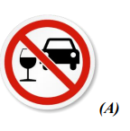 | A. You mustn't drive after drinking.  B. You shouldn't drive under the influence of drugs.  C. You must be careful with drunk drivers.  D. You should be careful as there is a pub ahead.

Question 3. On the way, you can see this sign and it says:
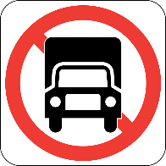 | A. The trucks aren’t allowed to move into this way.  B. The trucks must turn on lights when moving.  C. The black trucks must be allowed to move.  D. The black trucks can’t move when lights are working.
Question 4. When you see this sign in a public place, it means:
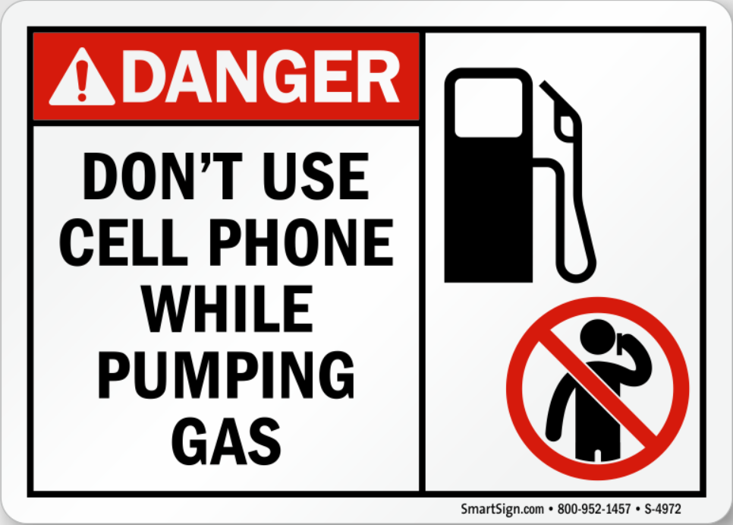 |  | A. Using mobile phones is allowed when pumping gas.  B. Using mobile phones is prohibited when pumping gas.  C. Making a phone call when pumping gas is possible.  D. Using mobile phones isn’t dangerous when pumping gas.

Question 5. On the way, you can see this sign and it warns that:
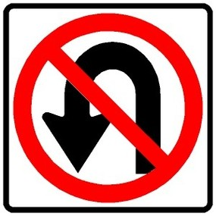 | A. Road closed ahead.  B. No left turn.  C. No U-turn permitted.  D. No passing zone.
Question 6. Seeing this sign, you must _______________.
 |  | A. turn right  B. go ahead only  C. get out of your car  D. drive faster

Question 7. What does the sign say?
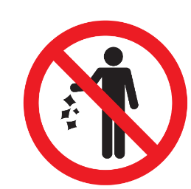 | A. Waste is not available in this place.  B. You don’t need to litter in this place.  C. You mustn’t throw trash on the ground.  D. Littering is not good for the environment.

Question 8. What does the notice say?
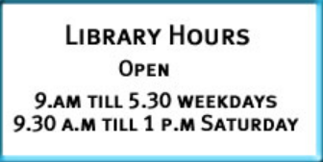 | The library ...  A. is open 5 days a week  B. closes later on Saturday  C. is not open on Sunday  D. closes early on Sunday
Question 9. What does the sign mean?
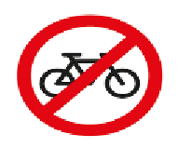 | A. You can cycle here.  B.You can’t park here.  C. You can’t cycle here.  D. You can park here
* Choose the word or phrase that is CLOSEST in meaning to the underlined part in each of the following sentences.
1. I’ll take the new job whose salary is fantastic.
A. reasonable B. acceptable C. pretty high D. wonderful
2. I could see the finish line and thought I was home and dry.
A. hopeless B. hopeful C. successful D. unsuccessful
3. Carpets from countries such as Persia and Afghanistan often fetch high prices in the United States.
A. Artifacts B. Pottery C. Rugs D. Textiles
4. Parents interpret facial and vocal expressions as indicators of how a baby is feeling.
A. translate B. understand C. read D. comprehend
5. This is the instance where big, obvious non-verbal signals are appropriate.
A. situation B. attention C. place D. matter

*Choose the word or phrase that is OPPOSITE in meaning to the underlined part in each of the following sentences
1. There is growing concern about the way man has destroyed the environment.
A. ease B. attraction C. consideration D. speculation
2. Fruit and vegetables grew in abundance on the island. The islanders even exported the surplus.
A. large quantity B. small quantity C. excess D. sufficiency
3. Unless the two signatures are identical, the bank won’t honor the check.
A. similar B. different C. fake D. genuine
4. He decided not to buy the fake watch and wait until he had more money.
A. authentic B. forger C. faulty D. original
5. Her father likes the head cabbage rare.
A. over-boiled B. precious C. scarce D. scare
* Choose the underlined part that needs correction in each of the following sentences.
1. A (A) Roadster is (B) the (C) automatic electric car (D).
2. They are use (A) wind energy (B) instead of (C) coal(D).
3. Her (A) car can carry (B) four passengers. Our (C) can carry seven passengers (D).
4. What (A) is the (B) meaning (C) of a (D) word “eco-friendly”?
5. Though he rode (A) a motorcycle, but (B) he didn’t (C) wear a helmet (D).
6. In the future, I think (A) we are travelling (B) much further (C) than we do (D) now.
7. He arrived (A) late. However (B) he left (C) the cinema early(D).
C. READING
I - Read the passage and choose the best option to answer each of the following questions.
We can use renewable and non-renewable energy sources to make electricity.Most of our electricity comes from power stations that use fossil fuels like coal, oil and gas. We call them non-renewable sources because they will eventually run out. Unfortunately, burning fossil fuels produces lots of greenhouse gases which cause global warming.We also use renewable energy souces like the sun, wind and water to make electricity. We can use them again and again because they cannot run out. They do not produce greenhouse gases so they are much less harmful to the environment.
1. Power stations use fossil fuels like to produce electricity.
A. coal, oil and gas B. coal and gas C. oil and gas D. natural gas
2. Burning fossil fuels produces which cause global warming.
A. greenhouse gases B. carbondioxide C. methan D. electricity
3. We can use the to make electricity.
A. sun and water B. sun and wind C. water and wind D. sun, wind and water
4. The renewable sources can be used again and again because they .
A. can run out B. cannot run out C. should run out D. shouldn’t run out
5. Renewable sources are harmful to the environment.
A. much more B. not less C. much less D. more than
II. Choose the correct answer A, B, C or D to fill each blank in the following passage.
A hoverboard can bring (1) ___________ a lot of benefits. It is self-balancing so it is safe for (2) ___________ . It is also fun because it connects to a music speaker with a phone, so riders can enjoy music while (3) ___________ on the road. It can also give riders a smooth (4) ___________. It runs on electric battery. Its run time is 30 minutes but you may have to wait 2-3 hours for the battery to (5) ___________. Because hoverboard are safe, easy to use, and inexpensive, they will (6) ___________around for long for the children to enjoy.
1. A. owners B. riders C. players D. speakers
2. A. beginers B. professionals C. adults D. children
3. A. hovering B. running C. driving D. surfing
4. A. drive B. ride C. fly D. cycle
5. A. be B. live C. work D. get
III.Read the passage and decide whether the statements are True (T) or False (F).
My uncle is working at a car company. His company is now developing a new flying car. The car will have solar panels on its roof and wings, and it will charge its battery as it moves. During light traffic, you can use roads. But in heavy traffic, you can use the flight mode to avoid traffic. It will be able to carry eight passengers. The car will have an autopilot function, so a driver is not needed. All passengers can relax, read books or play games while travelling. I was worried about the safety because it is driverless, but my uncle said it will be much safer than a traditional car. It will also be more comfortable and greener because it is solar-powered.
1. The writer’s father is working at a car company.
2. The car runs on solar energy.
3. You can use it in flight mode when roads are crowded.
4. You have to be very careful and skillful drivers to drive this car.
5. It will be more comfortable than a traditional car.
IV. Complete each of the following sentences using the cues given. You can change the cues and use other words in addition to the cues to complete the sentences.
1. Every country/ should do/ something/ control/ population.
A. Every country should do something to control population.
B. Every country should did something to control population.
C. Every country should do something control population.
D. Every country should do something to controlling population.
2. I/ be/ most interested/ hyperloop/ skytrain.
A. I am most interested to the hyperloop and sky train.
B. I am most interested in the hyperloop and sky train.
C. I am most interested for the hyperloop and sky train.
D. I am most interested of the hyperloop and sky train.
3. Solar power/ depend/ weather condition/ operation.
A. Solar power depends to weather conditions for operation.
B. Solar power depends weather conditions for operation.
C. Solar power depends on weather conditions for operation.
D. Solar power depends under weather conditions for operation.
4. She/ participate/ Boryeong Mud Festival/ three/ year/ ago.
A. She participated to the Boryeong Mud Festival three years ago.
B. She participated in the Boryeong Mud Festival three years ago.
C. She participated on the Boryeong Mud Festival three years ago.
D. She participated off the Boryeong Mud Festival three years ago.
5. I/ enjoy/ watch/ film/ made/famous/ Hollywood film producers.
A. I enjoy watching films who are made by famous Hollywood film producers.
B. I enjoy watching films where are made by famous Hollywood film producers.
C. I enjoy watching films whom are made by famous Hollywood film producers.
D. I enjoy watching films which are made by famous Hollywood film producers.
V . Listen and complete each sentence with NO MORE THAN TWO WORDS.
1. Energy is classified into _________ groups.
2. The energy from _________ is called renewable energy.
3. Using renewable energy can reduce your _________ costs.
4. Non-renewable energy is limited and will _________in the future.

