UNIT 1

A VISIT FROM A PEN PAL

Planning date:25/07/2016

Teaching date:29/07/2016

LESSON 1 : - GETTING STARTED

- LISTEN AND READ

A / Aims : Introduce some famous places in Ha Noi and read the text for details.

B/ Objectives : By the end of the lesson , Ss will be able to introduce their fatherland to a foreigners pen pal about some places of interest in Ha Noi such as Hoan Kiem lake , Ho Chi Minh museum , history museum

C / Teaching aids : books , cassette , chalks , board and some pictures .

D / Procedure :

Stages | Time | Activities/ Techniques | Materials
Warm up | 5’ | Guide students to play a game about some famous places in HaNoi  Places in Hanoi  T divides class into 2 teams, calls one from each to write out the places. After 1 minute, which team gets more will be the winner.  Suggested answers :  Ha Noi Opera House  Ho Chi Minh Mausoleum  Temple of Literature  History Museum  One pillar Pagoda  Explain the meanings of them to Students if they do not know. | Pictures, chalks, extraboard  TCs
Presentation  Practice | 17 | 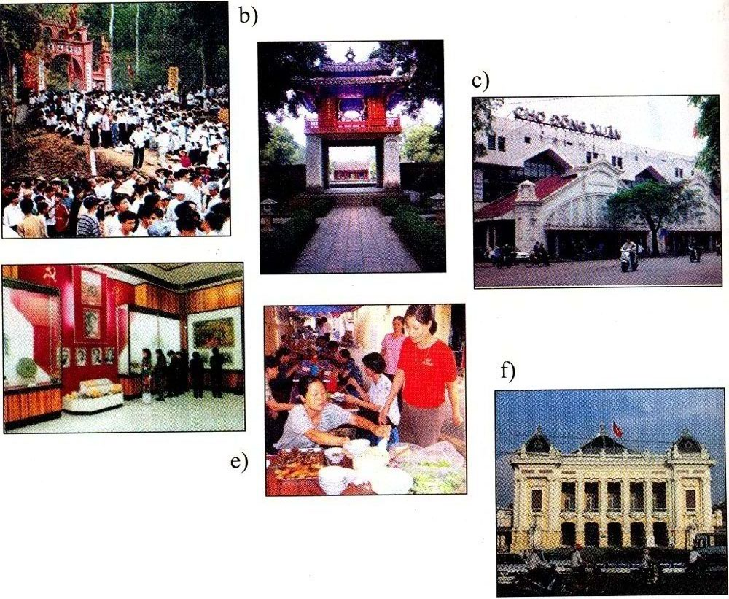  II / Pre reading :  - Ask Ss to listen and answer some questions :  + Do you have any pen pals ?  + Where does he come from ?  + Have you met her ?  =>If he visits Ha Noi , what will you introduce him?  - Introduce the topic of the lesson and set the scene “ Imagine that a foreign pen pal is coming to stay with you for a week . What activities would you like to do during the visit ? -the pictures in the book may help you “  - Call on some Ss to speak about places of interest with suggested models :  * Suggested models :  I think I will take my friend to the Ho Chi Minh Mausoleum, the Temple of Literature, and a famous restaurant to help my friend know about history of Vietnam and the famous food: Pho bo & bun cha  - In this lesson , Lan has a pen pal and this is the first time , this friend has come to Ha Noi .  * Explain some new words  1/ New words:  - Correspond (v) : (communicating by mail): trao đổi thư từ  - Be impressed by : (translation): có ấn tượng  - Friendliness ( n) (explanation): sự mến khách  - Mosque (n) :nhà thờ hồi giáo  - Peaceful atmosphere ( n) : (Translation): bầu không khí yên bình  - Keep in touch (v): giữ liên lạc  - pray (v): cầu nguyện, cầu khấn  + Used to + V infi  Example : Lan used to walk past the mosque on the way to her primary school .  - Checking technique : Rub out and remember  Correct and give marks if necessary  2/ Prediction:  You predict and decide whether the statements are true or false :  a. Lan,s pen pal comes from Malaysia .  b. Kualar Lumber is a small city .  c. The girls visited Hang Luoc Street on Monday .  d. They will write letters to each other again.  - Collect their predictions and write on the board .  T writes them on the extra board, hang out and ask Ss to read aloud them.  They can guess if each sentence is true or fall. | DVD  Tcs  SB  Ss listen & answer individually  2-3 Ss stand up and say about the places of interest  Individually, Group, half and the whole class. T corrects the pronunciation  Checking  In pairs, they will guess the answer
Presentation  Practice | 16  5  2 | III / While reading :  - Turn on the tape ( 2 or 3 times )  - Call on some Ss to report their answers in front of class .  - Correct and give correct answers :  1.T 2 .F 3 . F 4.T  Have Ss read the text and do the exercise below :  - Call on some Ss to report their answers and correct mistakes if any . Then give correct answers :  1. C 2.B 3.D 4. B .  3/ Model sentences:  I wish you had a longer vacation .  => S + Wish + S + V (past simple )  - Ask them to read the text aloud and correct their pronunciation.  - Ask them to give some examples for it. T corrects | Ss listen to the tape. A volunteer reads  Pairwork  individually
Production | 10 | IV / Consolidation :  - Ask Ss to practice making sentences with structures  “ Used to + V & Wish + pat simple “  - Call on Ss to read their sentences in train . Correct them and explain if they are wrong . | One by one
HW and WS | 30’ |   V /  1. Learn by heart all new words and structures . then make 5 sentences for each one .  2. Prepare the next lesson  * Feedback : | Remember & take notes.

THE END

