UNIT 9: CITIES OF THE WORLD
LESSON 1: GETTING STARTED
Mini test | Name: | Class: | Score:
Look at the pictures and complete the blanks with the words given.
continent | design | landmark | tower
beach | symbol | palace | postcard
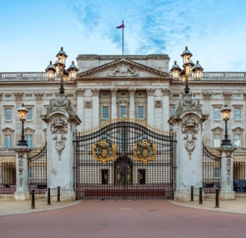 | 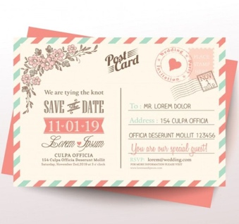 | 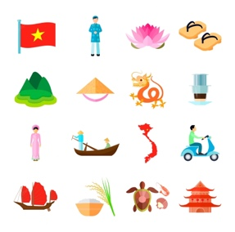 | 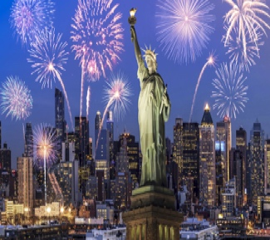
1. _________________ | 2. _________________ | 3. _________________ | 4. _________________
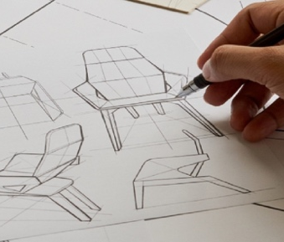 | 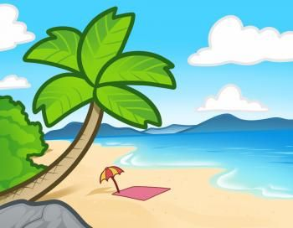 | 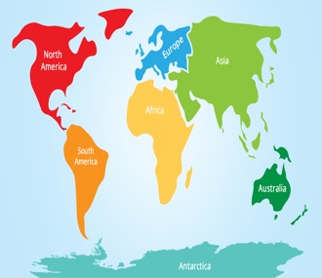 | 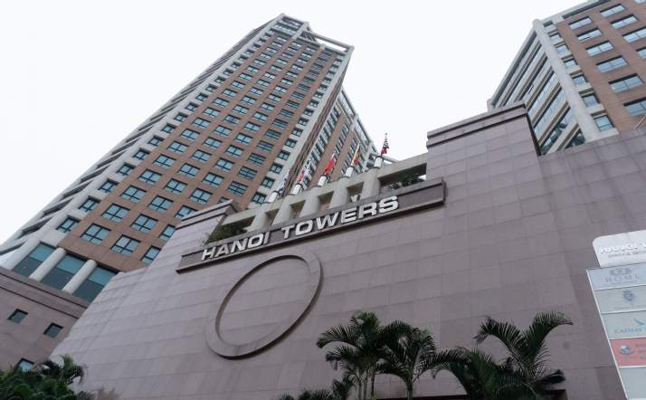
5. _________________ | 6. _________________ | 7. _________________ | 8. _________________

Reorder the words and phrases to make complete sentences.
1. photos / your / from / Are / these / holidays /? /
→ ____________________________________________________________________________
2. a lot / exciting / beaches / Sydney’s / with / of /. /
→ ____________________________________________________________________________
3. London / Big Ben / is / of / landmark / a /. /
→ ____________________________________________________________________________
4. places / to / lucky / You’re / many / visit /. /
→ ____________________________________________________________________________

Choose the best option to fill in the blank.
1. The Golden Gate Bridge is San Francisco’s most famous _________.
A. building B. monument C. palace D. landmark
2. _________ do you live in? - Asia.
A. Where B. What country C. What continent D. What city
3. "I have been to Nha Trang_____. How about you?"
A. one B. two C. two time D. twice
4. The package includes a tour of Sydney’s famous _________.
A. Opera House B. Eiffel Tower C. Big Ben D. White House
5. I really love living in Montreal _________ there are so many places to visit that are nearby.
A. but B. so C. because D. although

Complete the sentences with the suitable words given.
well-known | symbols | designer | flights
interesting | been | exciting | buildings

1. New York is an ________ city with many skyscrapers.
2. Ben Thanh Market is one of the most famous_________of Ho Chi Minh City.
3. Every week, there are two ________ from Ha Noi to HCM city.
4. Time Square in New York is crowded but _______.
5. Have you ever ________ to London?
6. Hoan Kiem Place is regarded as one of the ____ landmarks in Ha Noi.
7. There are many modern ________ in Ho Chi Minh City.
8. He was a talented_______. He created many great buildings in big cities.
ANSWER KEYS
Look at the pictures and complete the blanks with the words given.
1. palace 2. postcard 3. symbol 4. landmark
5. design 6. beach 7. continent 8. tower

Reorder the words and phrases to make complete sentences.
1. Are these photos from your holidays.
2. Sydney’s exciting with a lot of beaches.
3. Big Ben is a landmark of London.
4. You’re lucky to visit many places.

Choose the best option to fill in the blank.
1. The Golden Gate Bridge is San Francisco’s most famous _________.
A. building B. monument C. palace D. landmark
2. _________ do you live in? - Asia.
A. Where B. What country C. What continent D. What city
3. "I have been to Nha Trang_____. How about you?"
A. one B. two C. two time D. twice
4. The package includes a tour of Sydney’s famous _________.
A. Opera House B. Eiffel Tower C. Big Ben D. White House
5. I really love living in Montreal _________ there are so many places to visit that are nearby.
A. but B. so C. because D. although

Complete the sentences with the suitable words given.
1. New York is an exciting city with many skyscrapers.
2. Ben Thanh Market is one of the most famous symbols of Ho Chi Minh City.
3. Every week, there are two flights from Ha Noi to HCM city.
4. Time Square in New York is crowded but interesting.
5. Have you ever been to London?
6. Hoan Kiem Place is regarded as one of the well-known landmarks in Ha Noi.
7. There are many modern buildings in Ho Chi Minh City.
8. He was a talented designer. He created many great buildings in big cities.

